**DSA Lab Manual**

**Submitted by:**

**Basit Ali**

**Submitted to:**

**Mam Noreen**

**Registration No:**

**S23BSCS012**

**Section:**

**A**

**Course:**

**Data Structure and Algorithm**

**Semester:**

**3rd**

**Assignment 02**

Q1: Modify the example #6 lab#2, insert at least three new

elements e1,e2,e3 at index 0,2,4 respectively?

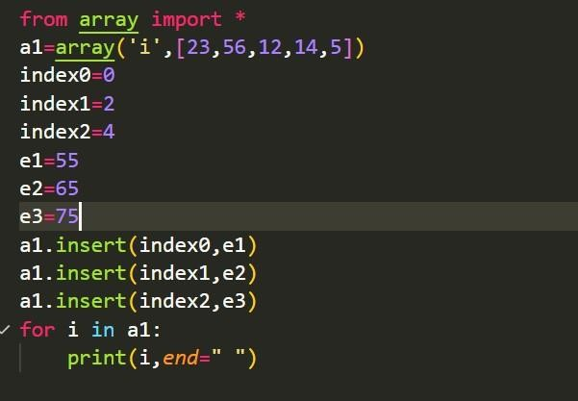

**Output Of The above program is:**

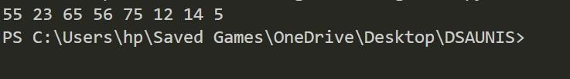

Q2: consider an array[33,44,55,33,80] the remove the element 33 from the list. Your resultant array should be [44,55,80]?

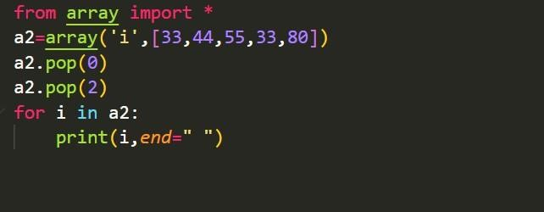

**Output of the above Program:**

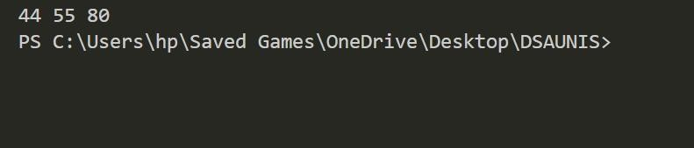

**ASSIGMENT 03**

Q1: Write a program to sort a list of elements in reverse order (descending order)? And

Q2: Concatenate at least three lists by using extends function?

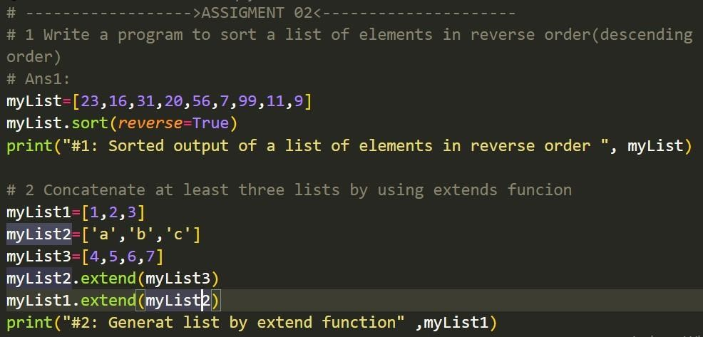

**Output of Above Program**

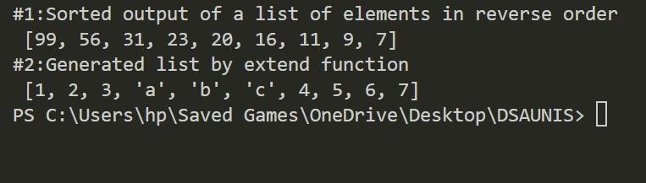

**Assignment 04**

Q1: Repeat the example 3 lab4 without using the init() function?

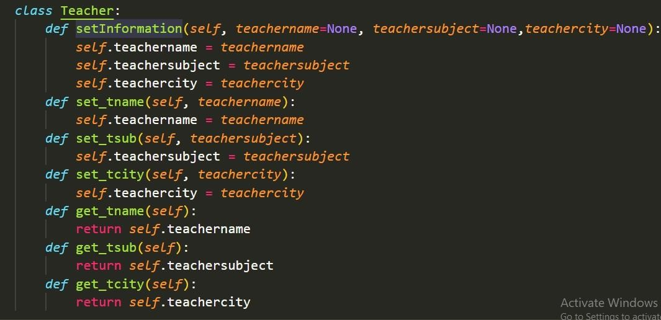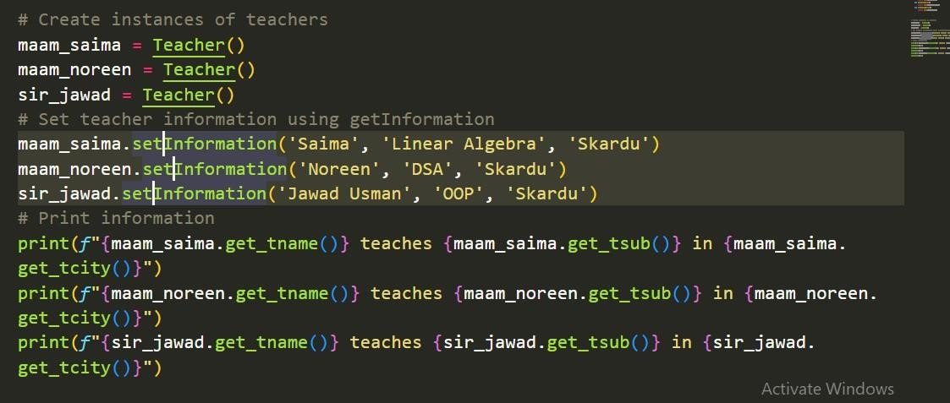

**Output of the above Program**

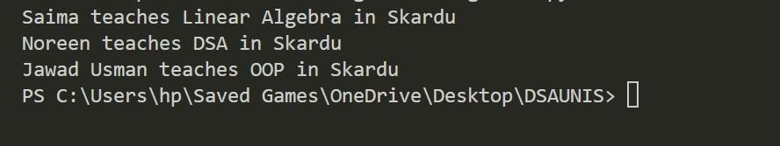

**ASSIGNMENT 05**

Q1: Modify the example #1 and #2 lab #5 by inserting three items roll_no,name and cgpa in the data part. Compile both of the example 1 and 2 as a one program?

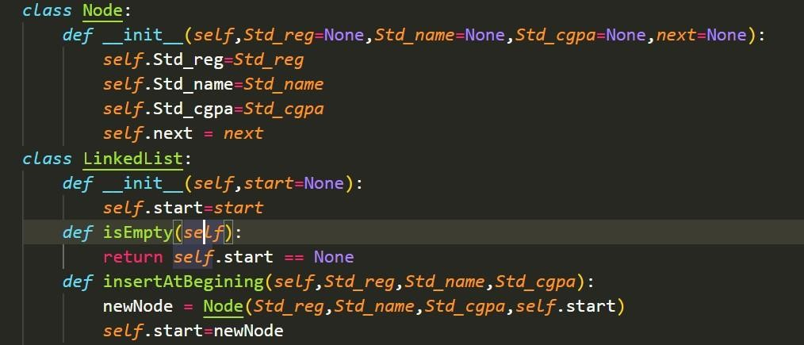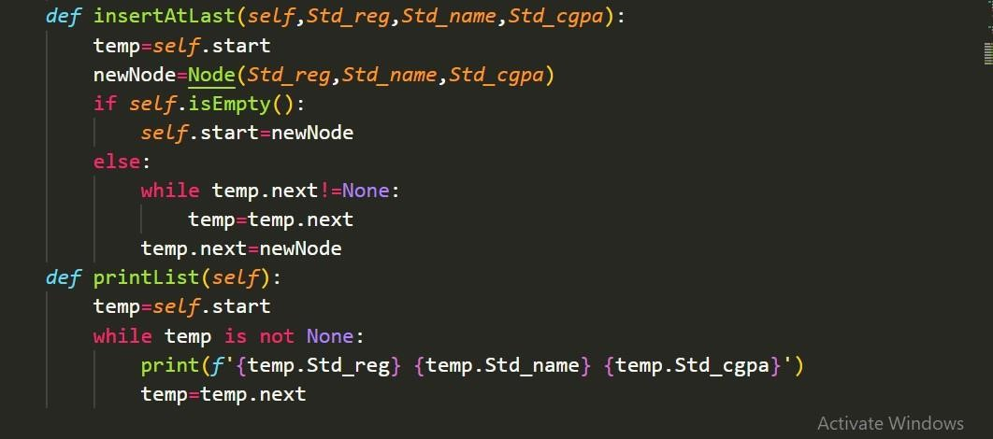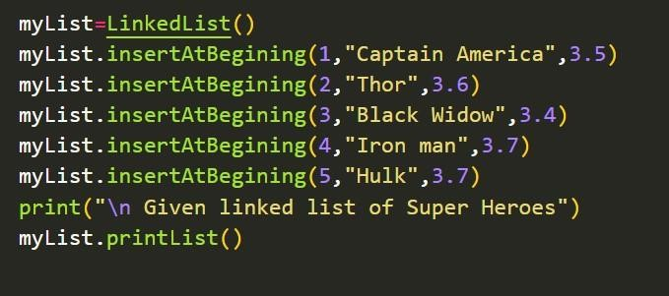

Output Of the above Program is :

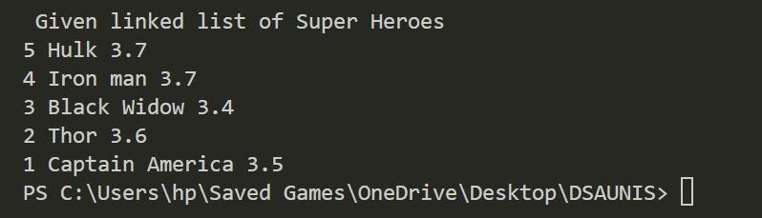

**ASSIGMENT 06**

Q1: Add new functions insert_At_Sec and Insert_At_Sec_Last in the above program lab#6 exp#1 to add the data at second postion and second last postion in linklist?

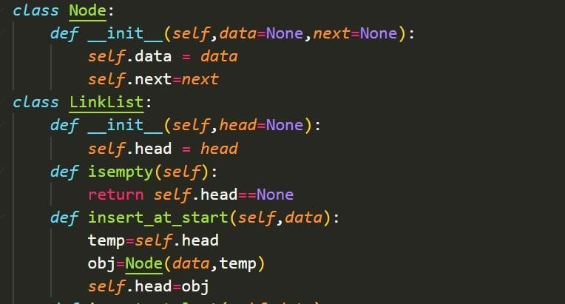

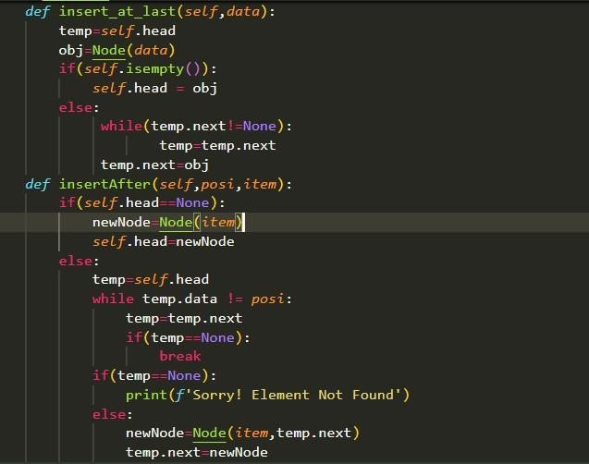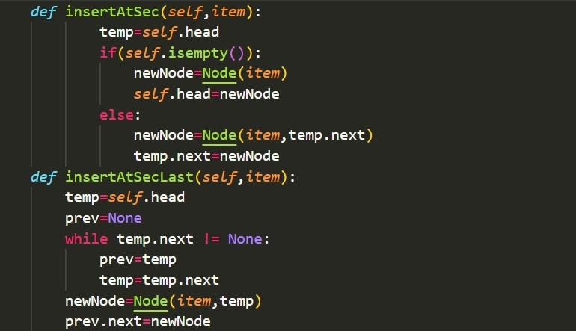

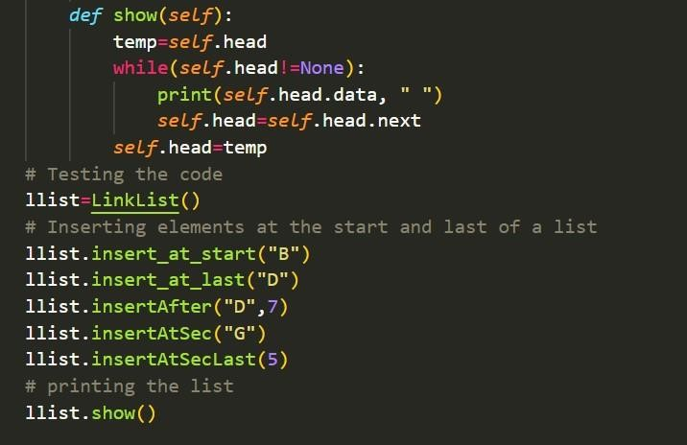

**Output is:**

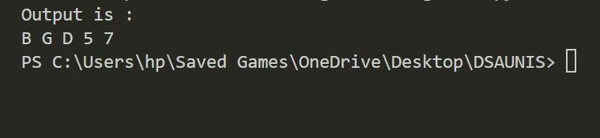

**ASSIGMENT 07**

Q1: Write a program to delete the specific element from the link lists?

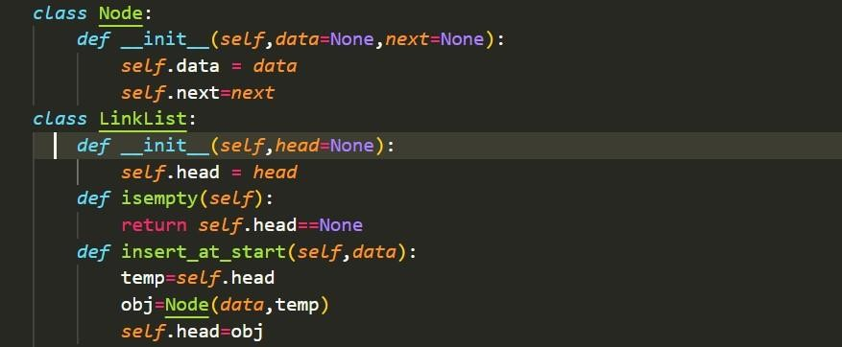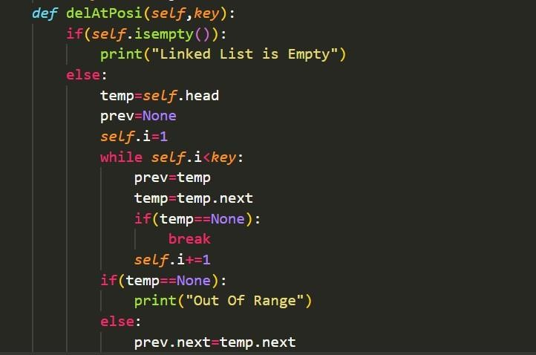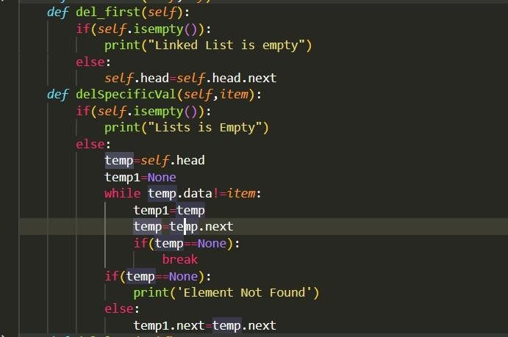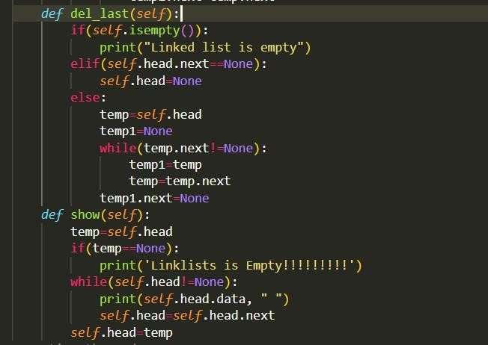

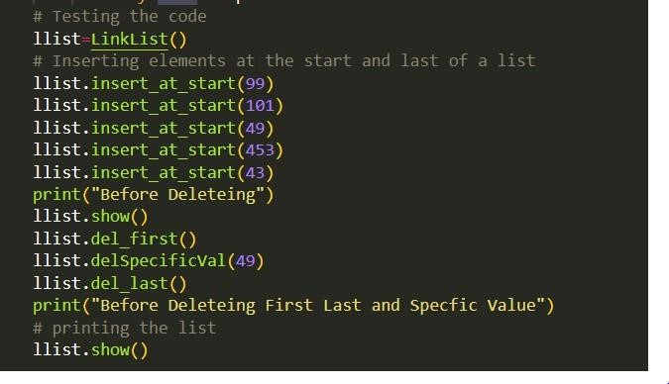

**Output of the Program:**

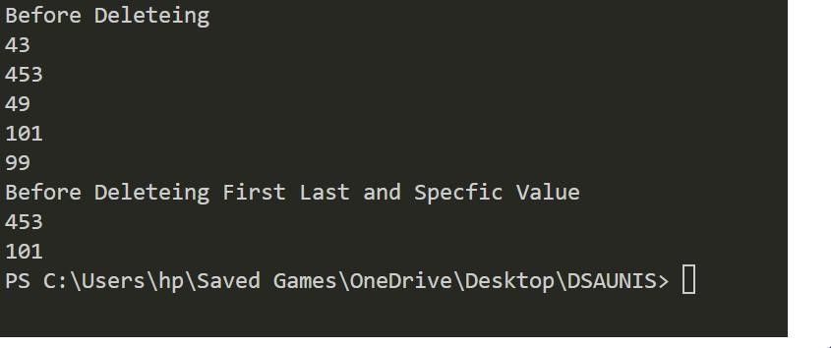

**ASSIGMENT 08**

Q1: Write a code to Stack using link list?

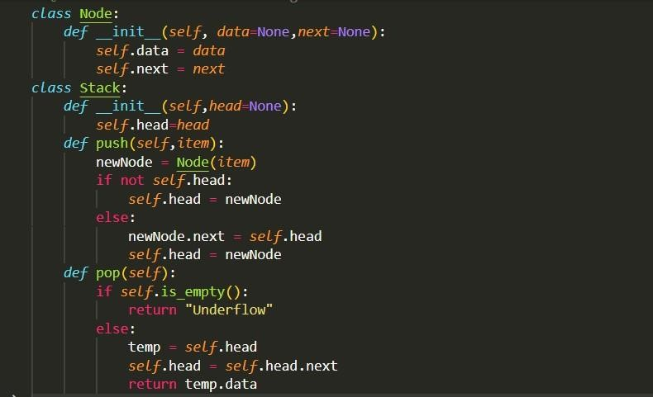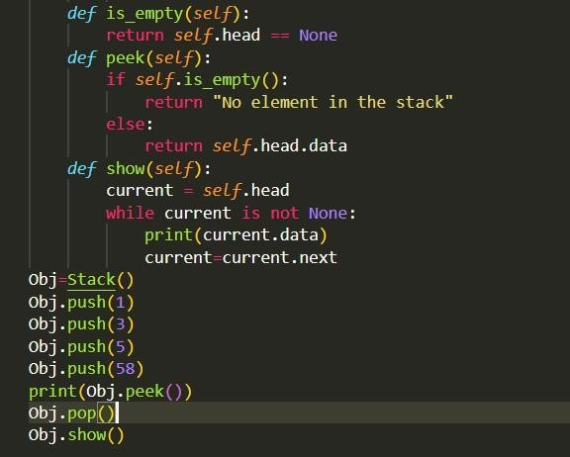

**Output Of the Program is:**

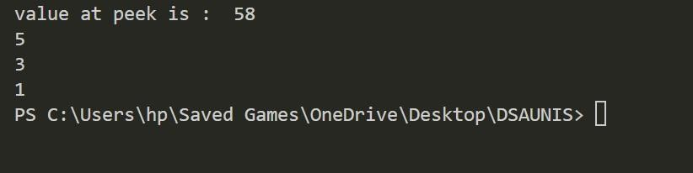

**Assignment 09**

**Program 01:**

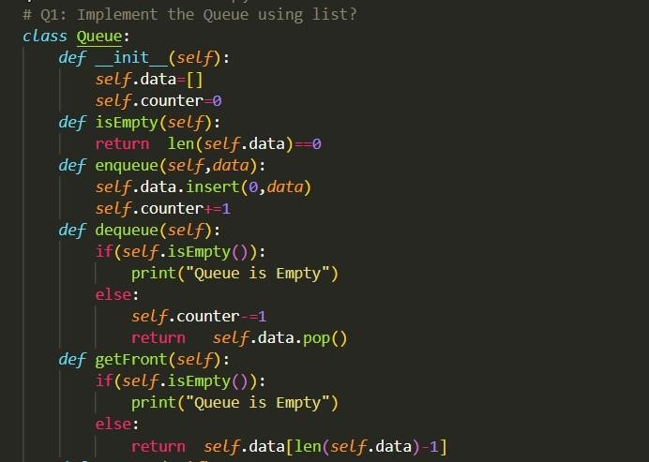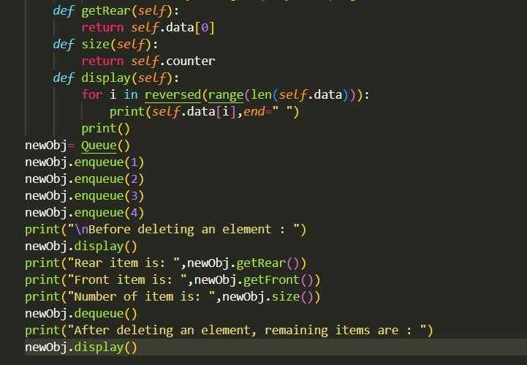

**Output Of Program Is:**

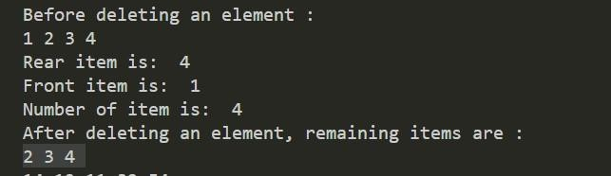

**Program 02:**

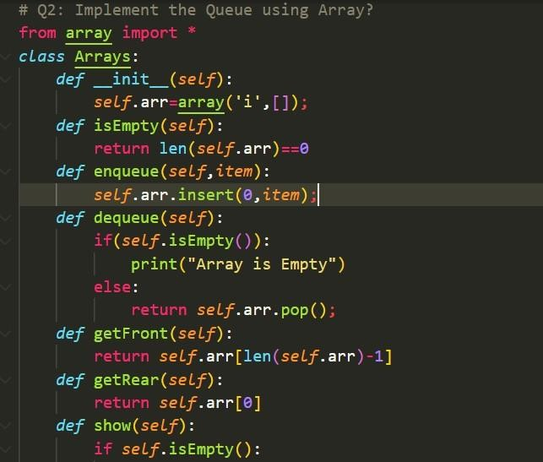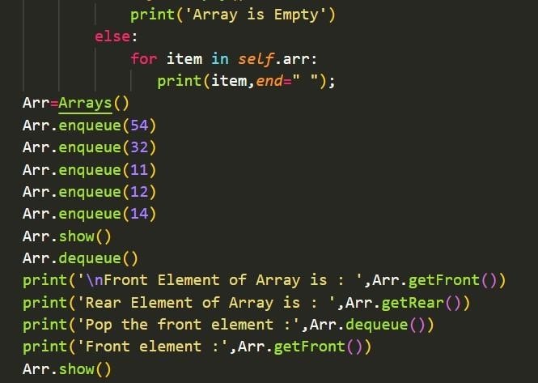

**Output Of Program Is:**

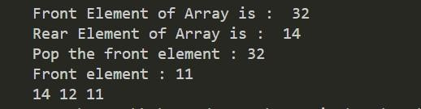

**Assignment 10:**

**Program 01:**

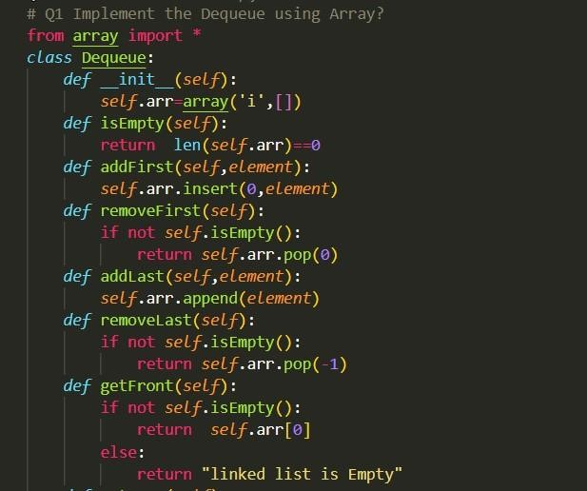

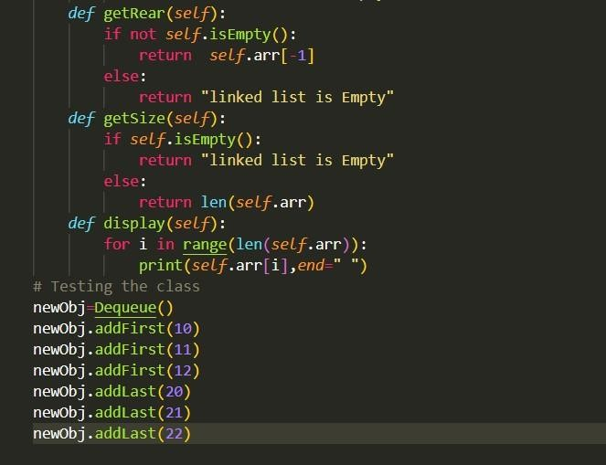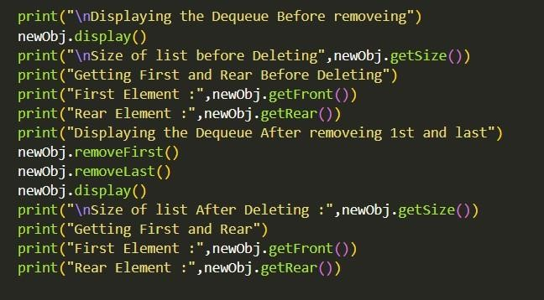

**Output Of The Program Is:**

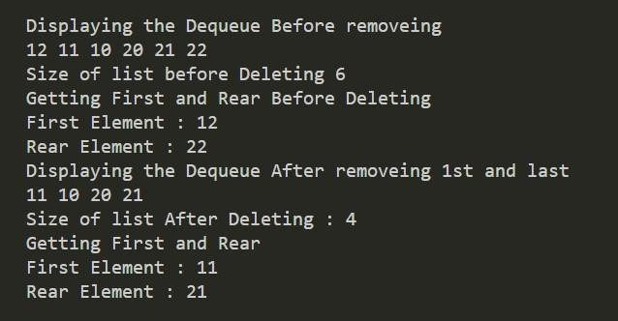

**Program 02:**

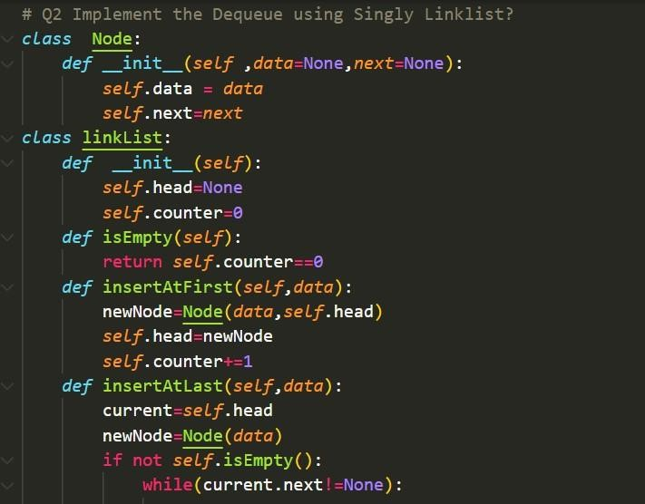

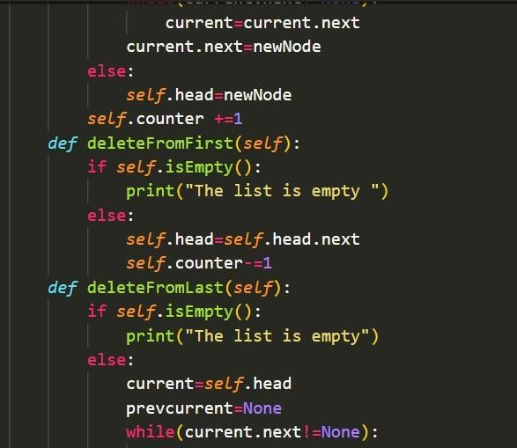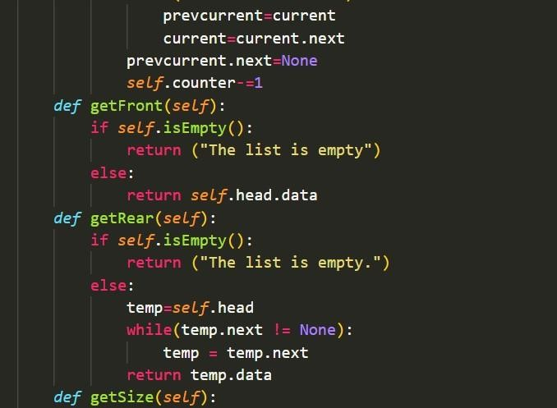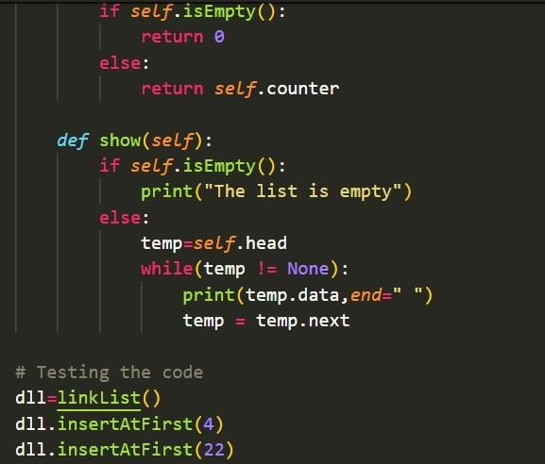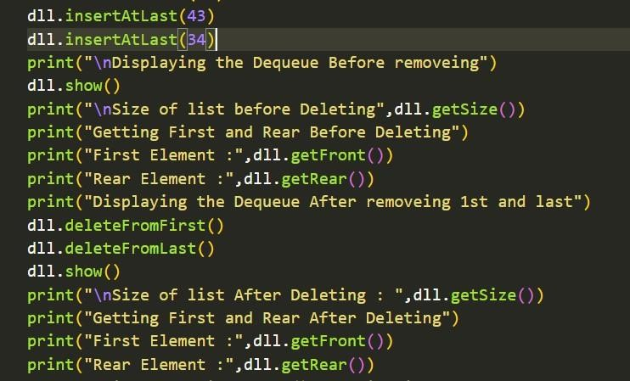

**Output Of The Above Program is:**

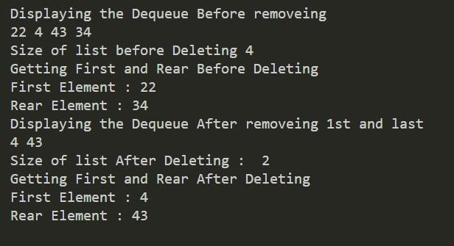

**Program 03:**

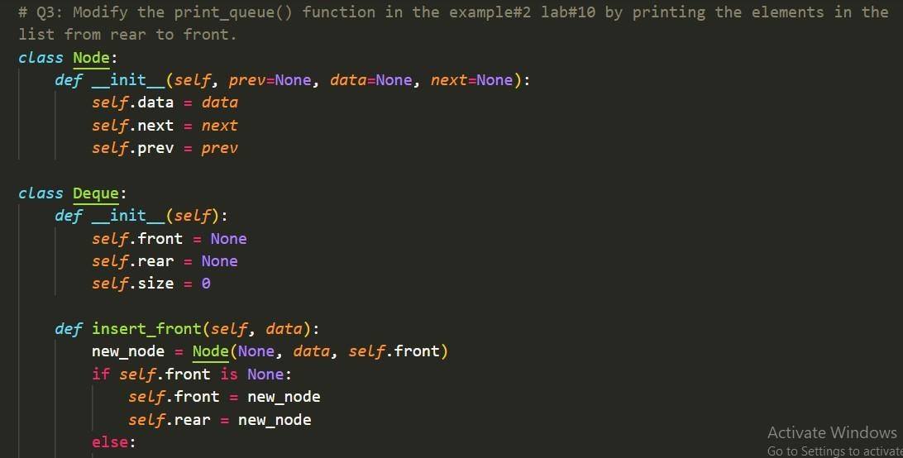

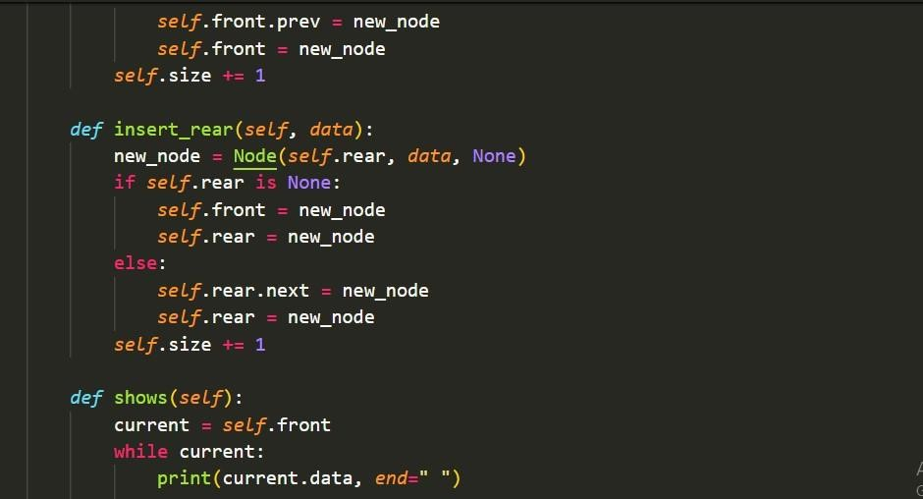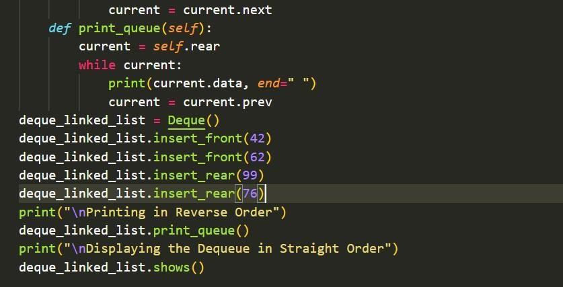

**Output Of The Program Is:**

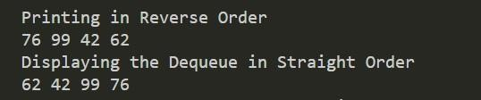

**Assignment 11**

**Program 01:**

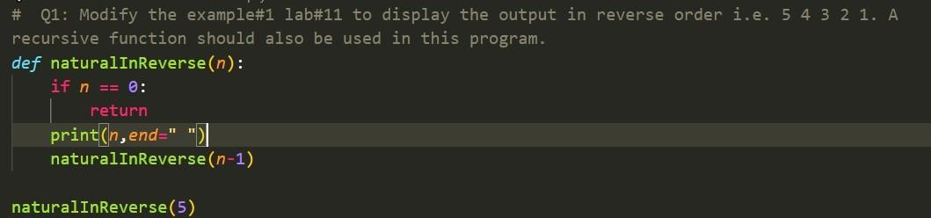

**Output Of Program Is:**



**Program 02:**



**Output Of Program Is:**



**Program 03:**

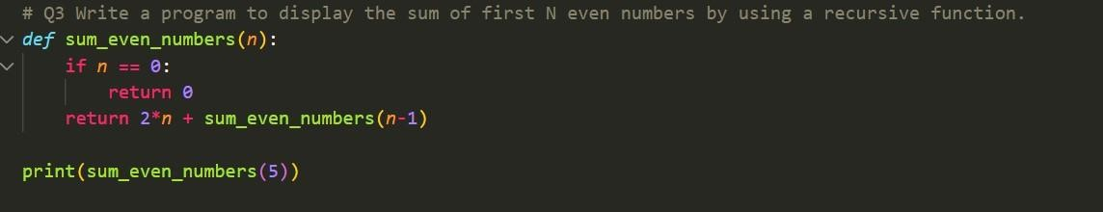

**Output Of Program Is:**



**Lab:NO:13**

Q: Modify the program LAB#12 example#1 by creating two trees in this same program. Insert four number of items in the first tree and five number of items in the second tree. Explain the code diagrammatically.

Note:

Implement two binary search trees one by one.

**1**

Similar elements are not allowed in a binary search tree.

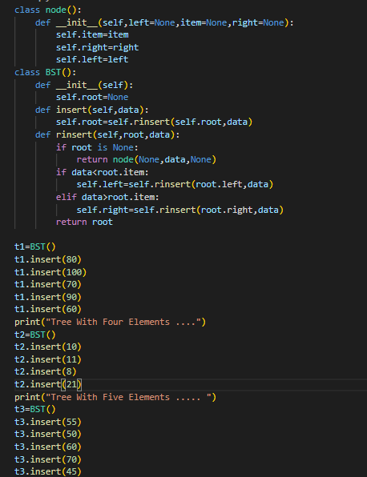

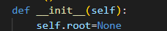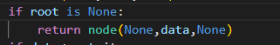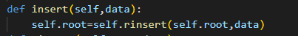

**None 10 None**

**500**

**Self.root=None**

**data=10**

**UPDATE**

**Self.root=500**

**Self.root=None**

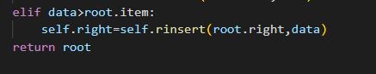

**UPDATE**

**Self.root=500**

**Root.right=550**

**Self.root=500**

**Root.right=None**

**Self.root=500**

**data=11**

**None 11 None**

**550**

**2**



**3**

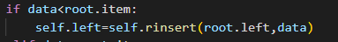

**Self.root=500**

**data=08**

**Self.root=500**

**Root.left=None**

**None 08 None**

**600**

**UPDATE**

**Self.root=500**

**Root.left=600**



**Self.root=500**

**Root.right=None**

**Self.root=500**

**data=21**

**Self.root=500**

**Root.right=550**

**Self.root=500**

**data=21**

**4**



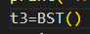 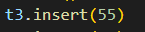 

**None 21 None**

**700**

**UPDATE**

**Self.root=500**

**Root.Right=700**

**Self.root=None**

**1**

NOW DIAGRAMMATICAL EXPLAINATION FOR THE ANOTHER TREE INCLUDING FIVE ELEMEMTS

**None 55 None**

**1000**

**UPDATE**

**Self.root=1000**



**Self.root=1000**

**Root.left=None**

**Self.root=1000**

**data=50**

**2**



**3**

**UPDATE**

**Self.root=1000**

**Root.left=2000**

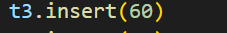

**None 50 None**

**2000**



**Self.root=1000**

**Root.rigth=None**

**Self.root=1000**

**data=60**

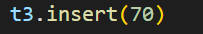

**Self.root=1000**

**Root.right=3000**

**Self.root=1000**

**data=70**

**None 60 None**

**3000**

**4**

**UPDATE**

**Self.root=1000**

**Root.right=3000**

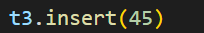

**None 70 None**

**4000**

**Self.root=1000**

**Root.right=None**

**5**

**UPDATE**

**Self.root=1000**

**Root.right=4000**



**None 45 None**

**5000**

**UPDATE**

**Self.root=1000**

**Root.left=5000**

**Self.root=1000**

**Root.left=None**

**Self.root=1000**

**Root.left=2000**

**Self.root=1000**

**data=45**

**Lab No 13:**

Lab#13

Q1: Add two more function preorder and post order traversal in the Example#1. Then explain the code of each function diagrammatically.

Program:

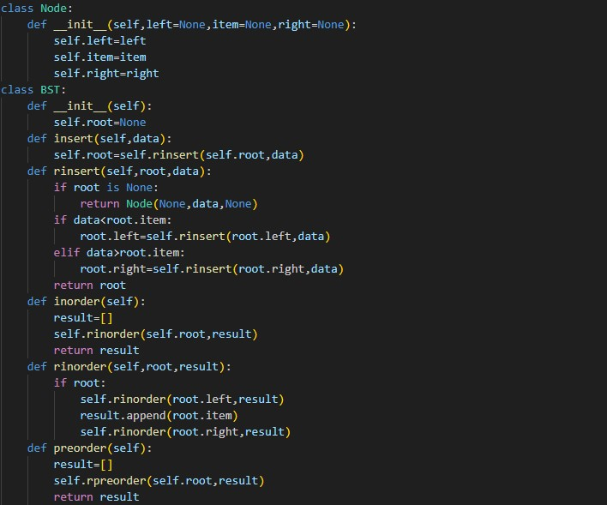

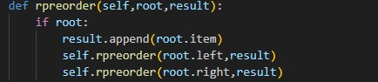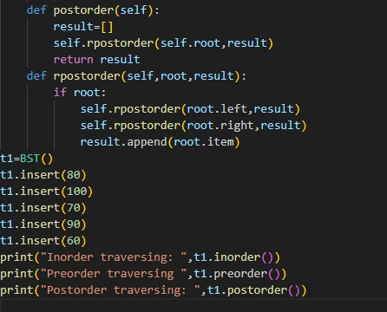

Output:



Explanation:

Return 80,70,60,100,90

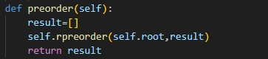

(1)

Root=80

= [80]

result

1)

2)

root.

Left=70

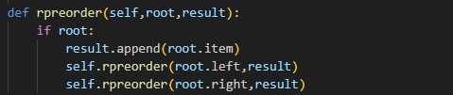

1

2

3

|  |  |  |  |  |  |
| --- | --- | --- | --- | --- | --- |
|  | | | |  | |
|  |  | 2) | |  | | --- | | 2.1 |  |  | | --- | | 2.2 |  |  | | --- | | 2.3 | | Root=70  1)Result  [80,70] 2)  root.Left=600 |  |
|  |
|  | | | |  | |

|  |  |  |  |
| --- | --- | --- | --- |
| |  | | --- | | 2.2) | | | |
|  | |  | | --- | | 2.2.1 |  |  | | --- | | 2.2.2 |  |  | | --- | | 2.2.3 |   Root=60  1)Result  [80,70,60]  2)  root.left:None |  |
|  | | |

Step 02 complete because the root. Left is none now step 03 will be start.in the step 03 root is 80 and root. Right is 90. when the root is 90 then root. Right is 100.

|  |  |  |  |  |  |
| --- | --- | --- | --- | --- | --- |
|  | | | |  | |
|  |  | 3 | |  | | --- | | 3.1 |  |  | | --- | | 3.2 |  |  | | --- | | 3.3 | | root=90  1)result  [80,70,60 90] root.right=  100 |  |
|  |
|  | | | |  | |

Root=

100

1)

result

60

,

[80,70

100,90]

Root.right=

None



3.3.1

3.3.2

3.3.3

3.3

The result is [80,70,60,100,90]

**Explanation of post order**

Return [60,70,90,100,80]

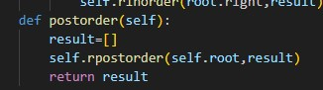

The root is 80.but the root.left is 70.it append 60 at first at in result.

Root=60

Result

[

=

60]

root.left=None

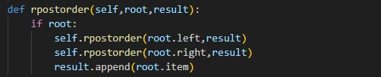

1

2

3

1

1.1)

|  |
| --- |
| 1.1.1 |
| 1.1.2 |
| 1.1.3 |

root=70 result = [60,70] root.left=60

root=

90

result=

[60,70

90

,

]

root.right=100



2.`1.1

2.1.2

2.1.3

2.1)

root=100

result=

[60,70,90,100]

root.right=None



2.2.1

2.2.2

2.2.3

2.2)

root=80

result

[60,70,

=

90

,

100,80]

root.left=70

root.right=90

result

[

=

60

,70,

90,100,80]



3.1.1

3.1.2

3.1.3

3.1)

80

1

3

append 70

3

append90

1

1

2

70

60

100

90

2

3append 80

1. 1
2. 2

2

3append 60 3append 100

RESULT IN Post order= [60,70,90,100,80]

**Lab No 14:**

Q1: Write a program to insert remove index in the lab#14 to remove any index.

Program:

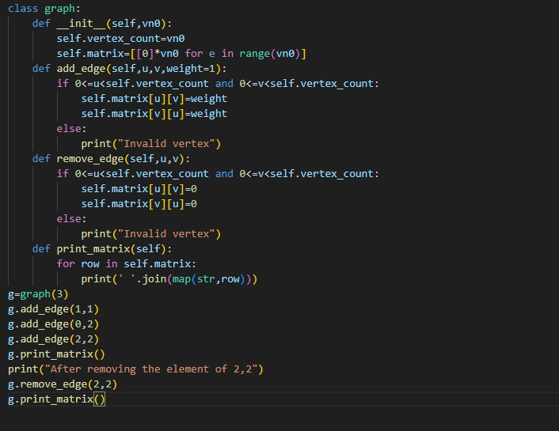

Output:

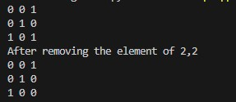

**Lab No 15:** Q1: In Lab#15 example 2 insert a new function to remove the edge and the weight is taken by the user?

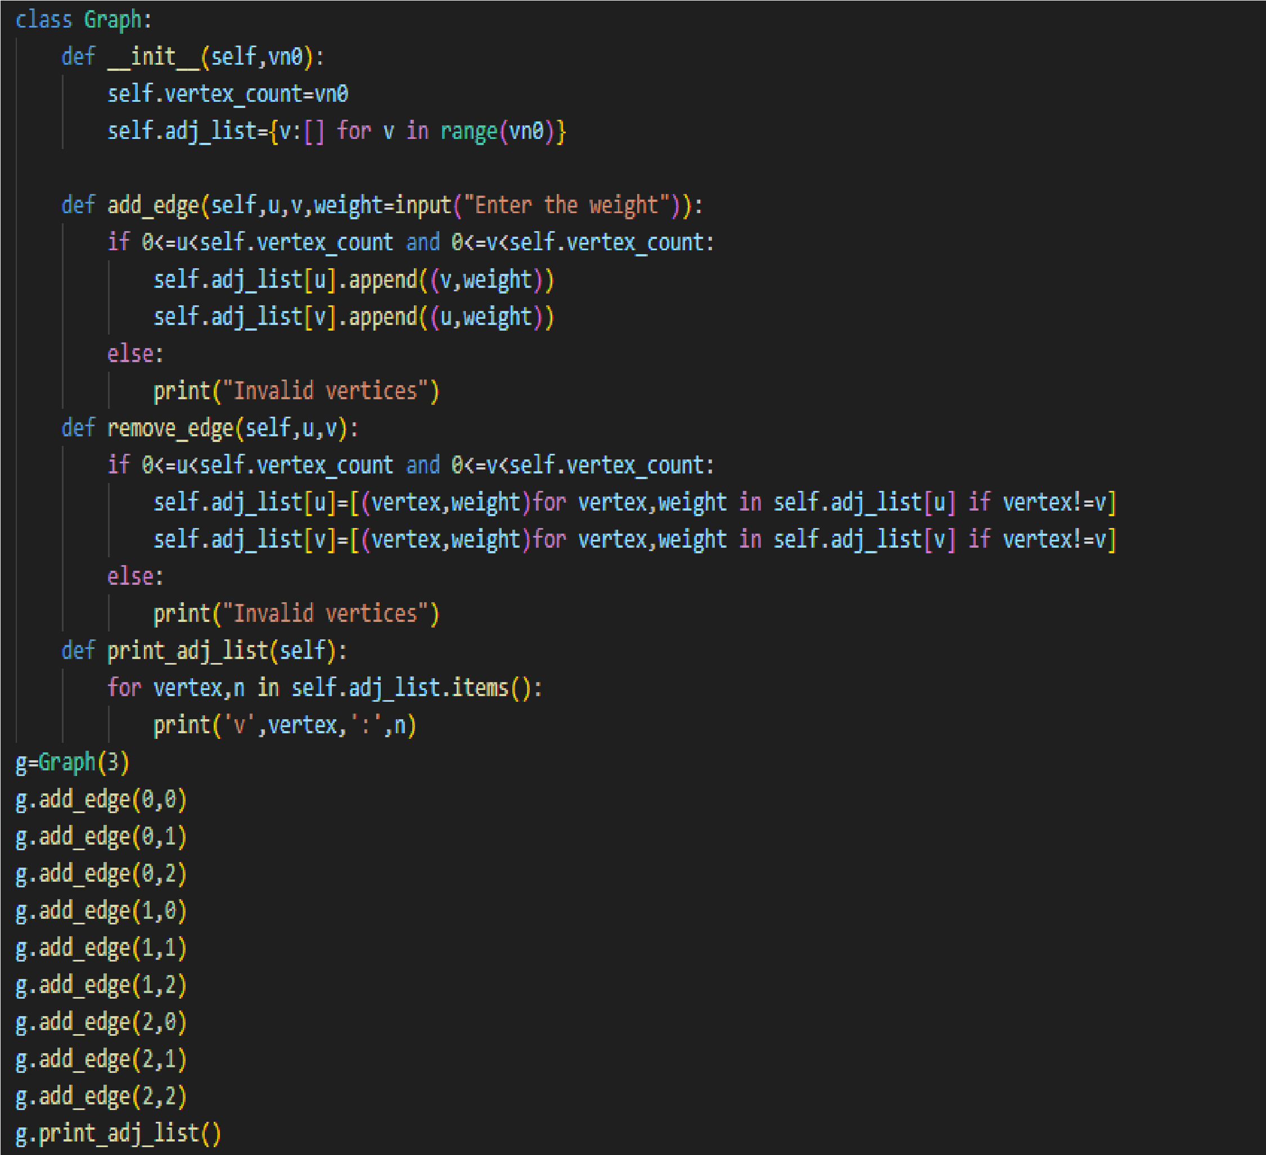Program 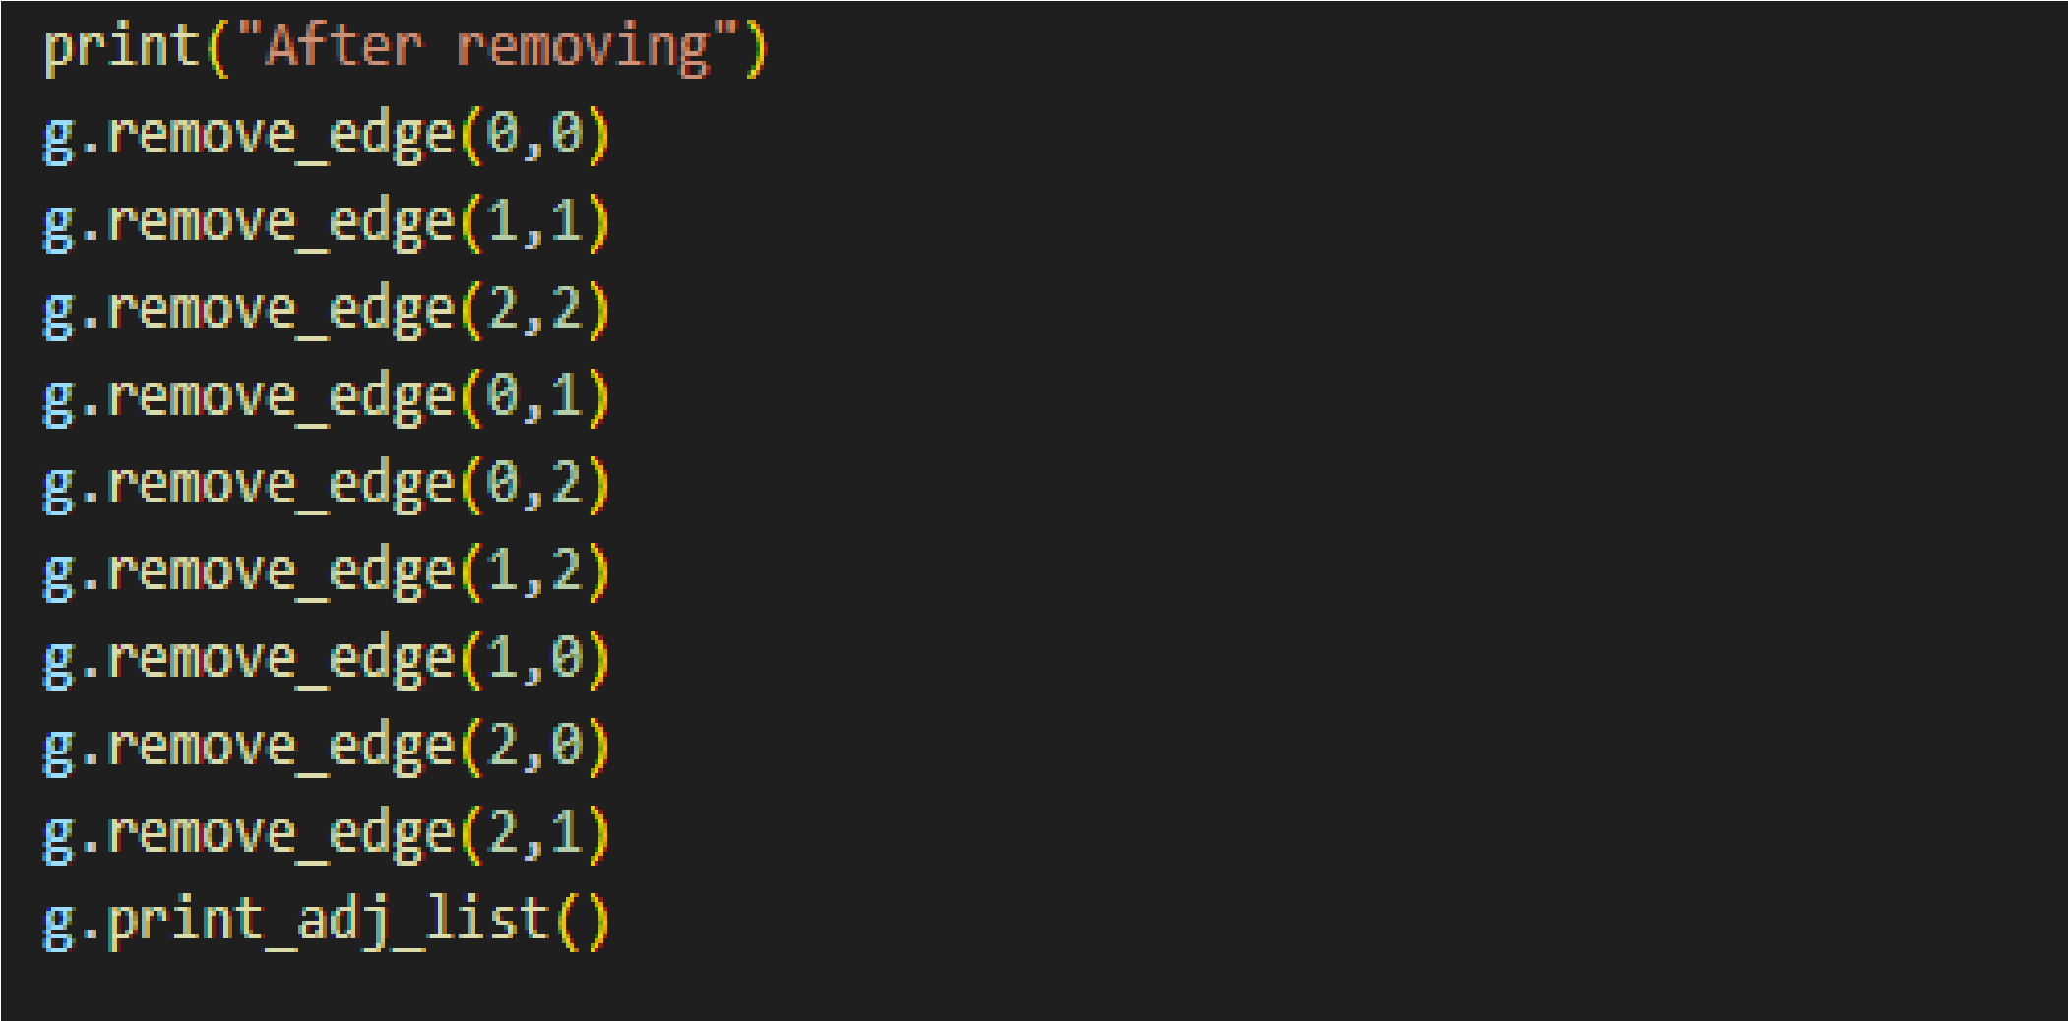Output:

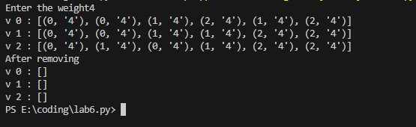

**LAB#17:**

Q1: Write a program of the given graph and print the output of this graph in topological order and also explain the code.

1

2

7

6

3

4

5

Program:

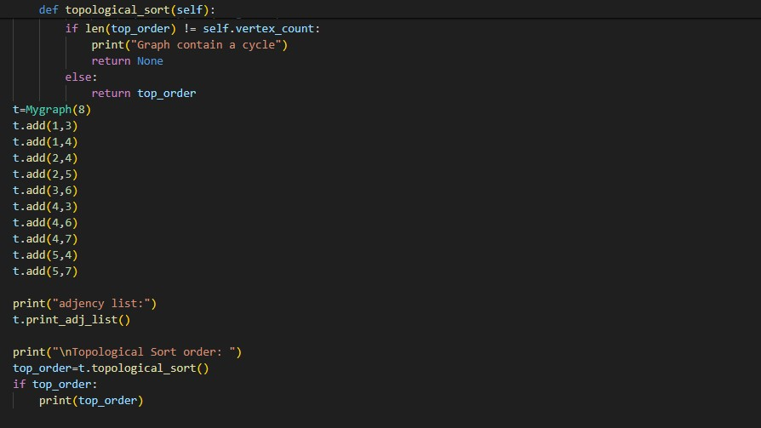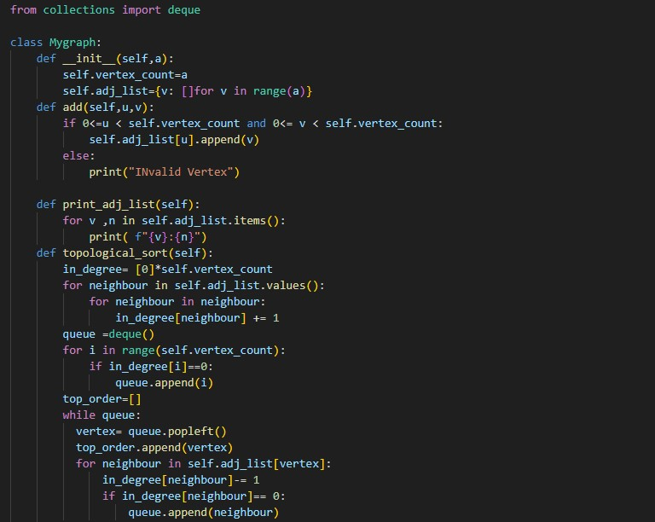 OUTPUT:

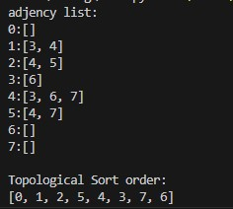

Explanation of code:

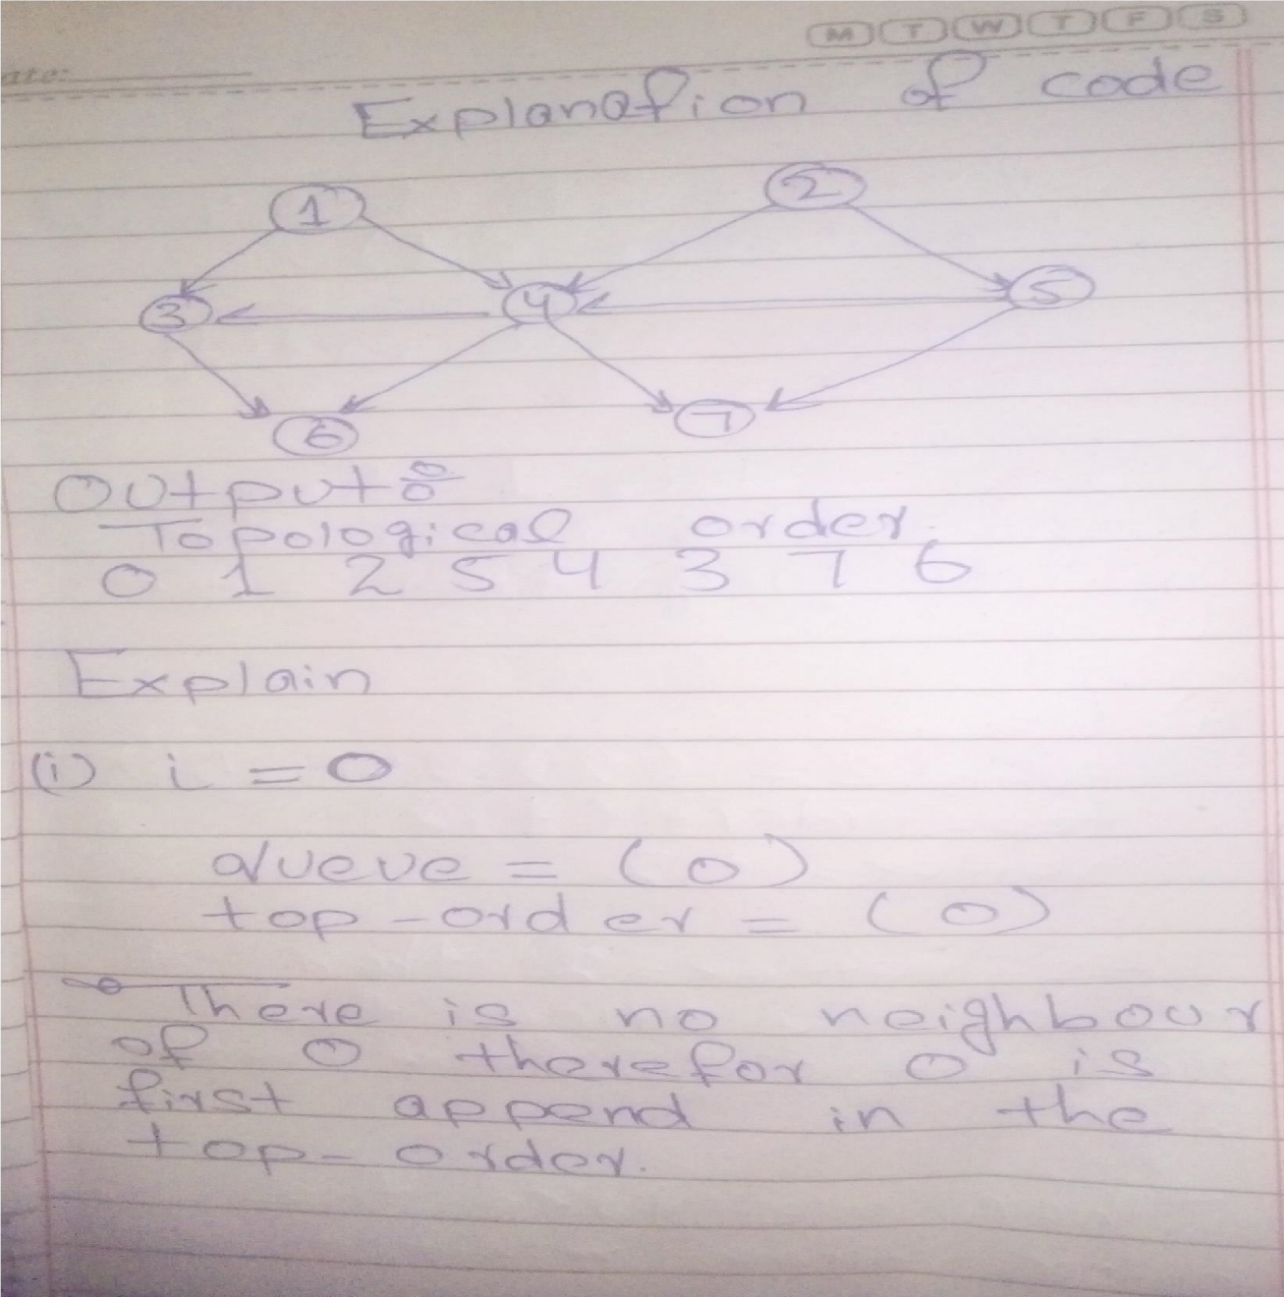

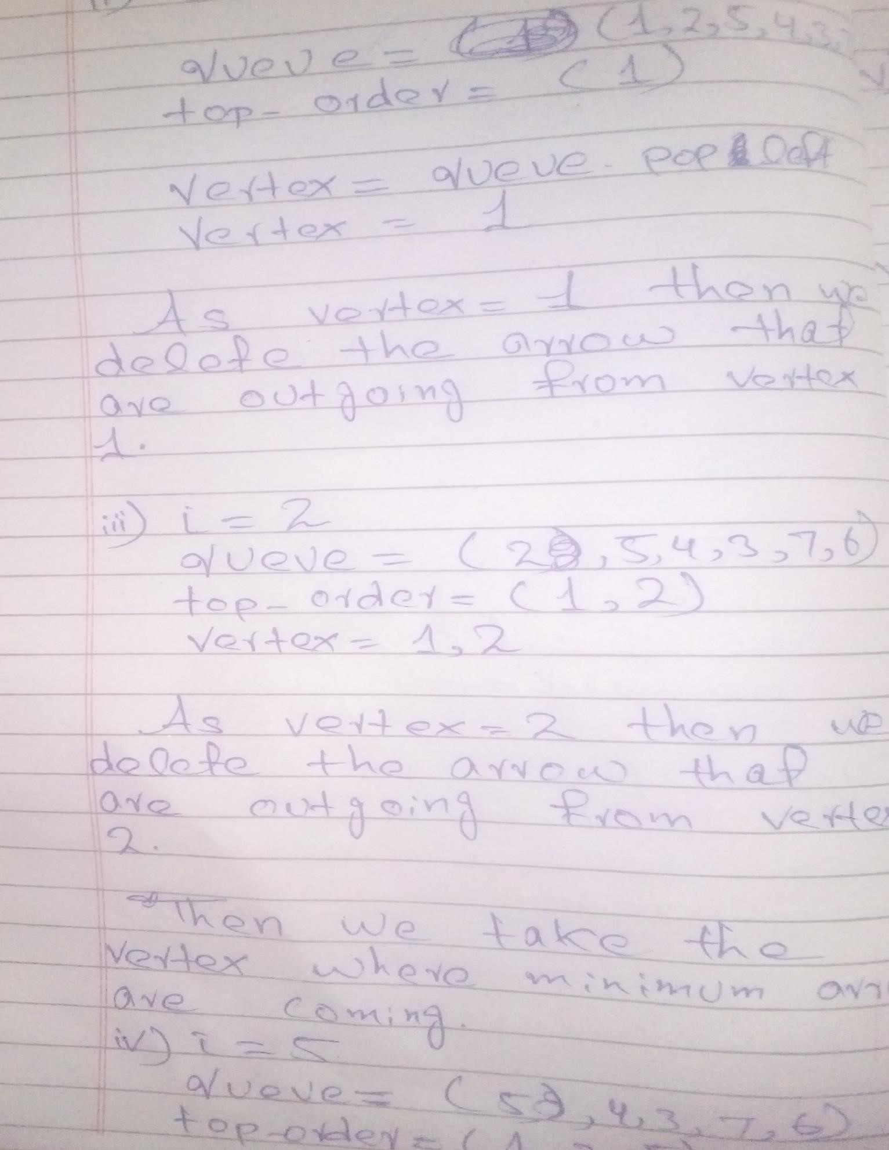

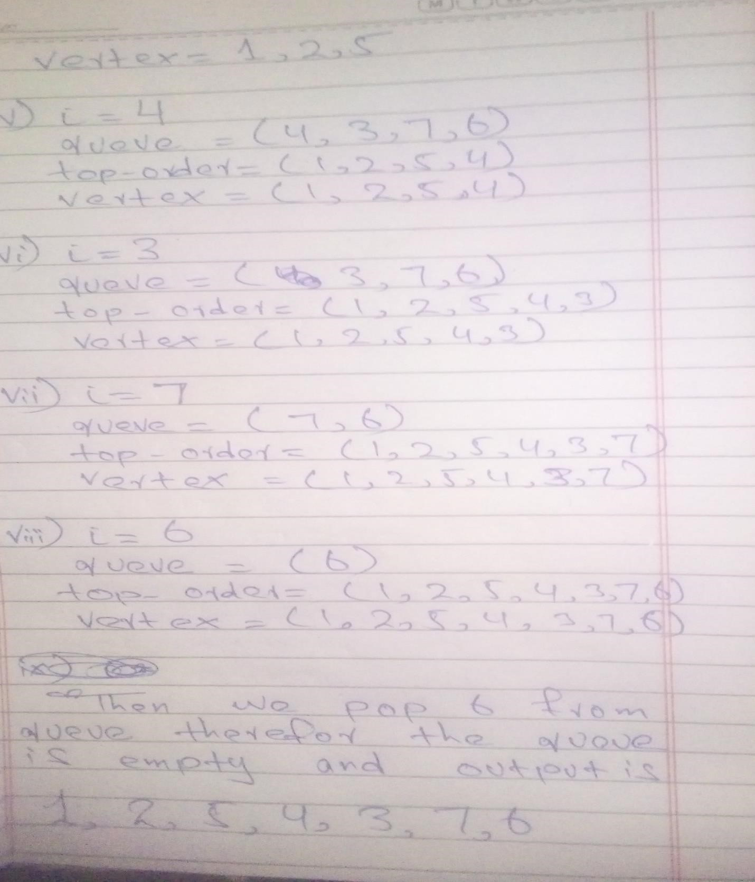

**Lab#18:**

Q1: Write a program that find a shortest path of above program of lab#18. We take the source vertex as 1.

*Program:*

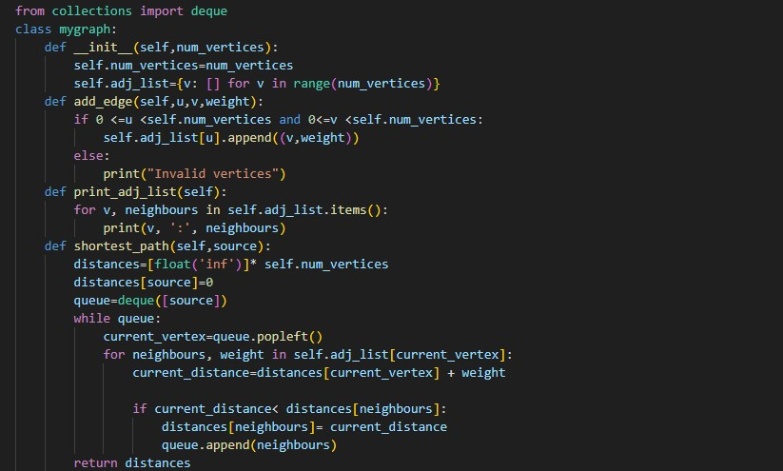

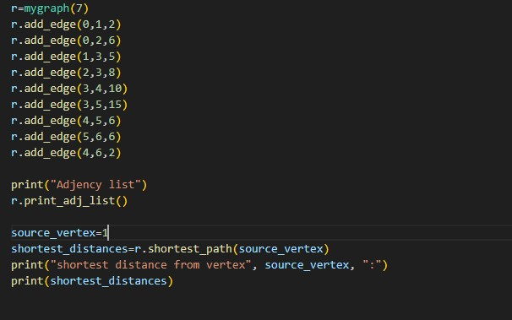

*Output*:

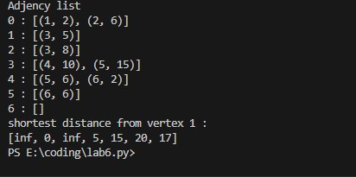

*Explanation:*

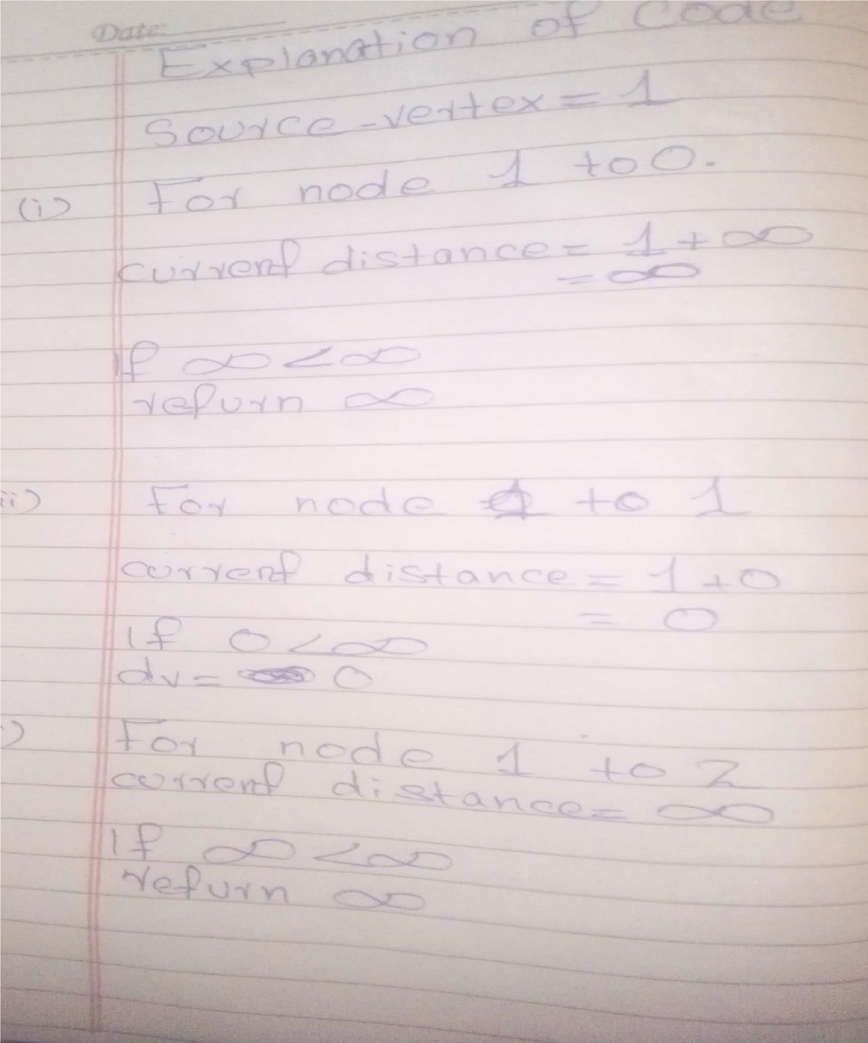

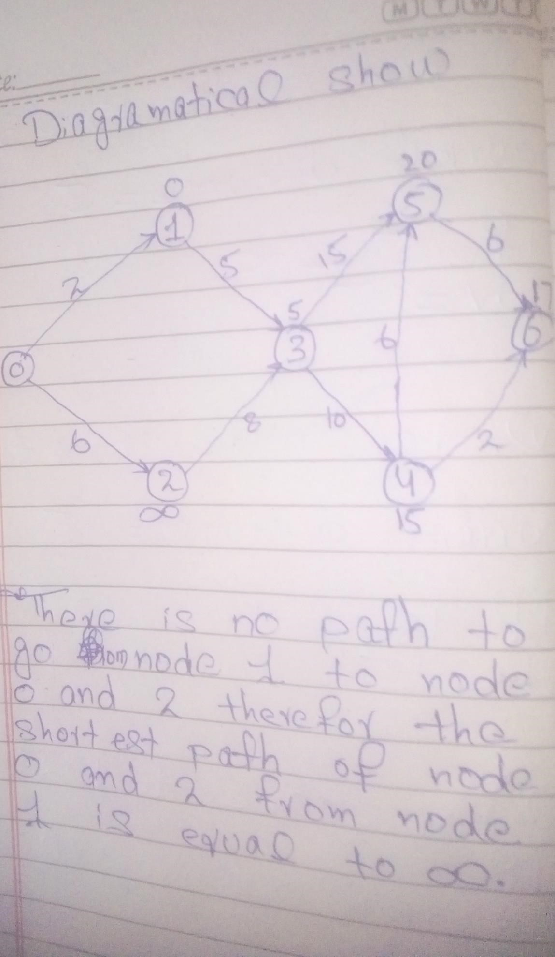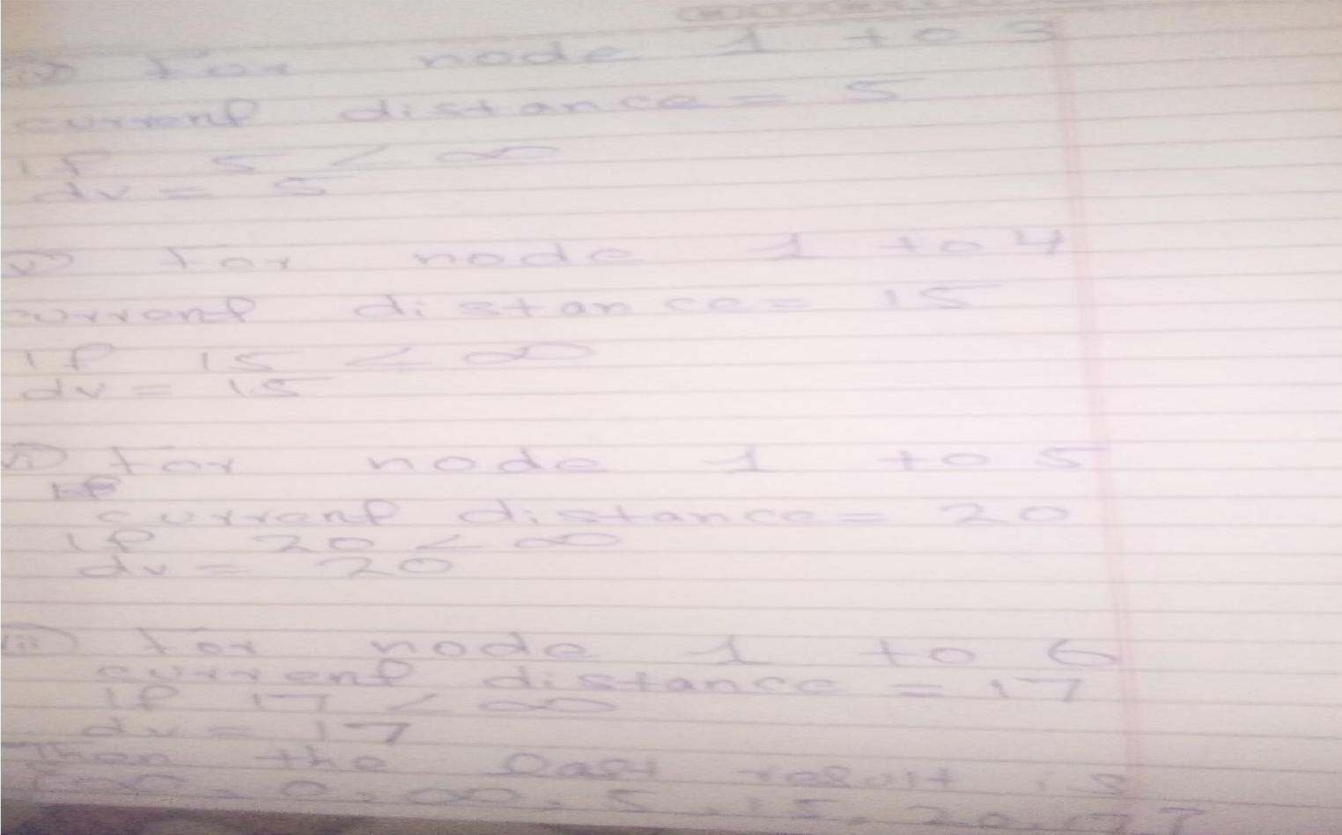

**Lab#19:**

**Q1:** Write a program to apply the merge sort algorithm on an unsorted dictionary to sort its values.

|  |
| --- |
| *def* merge_sort(*arr*): if len(*arr*) <= 1: return *arr* mid = len(*arr*) // 2 left = merge_sort(*arr*[:mid]) right = merge_sort(*arr*[mid:]) return merge(left, right)  *def* merge(*left*, *right*): merged = []  left_index, right_index = 0, 0 while left_index < len(*left*) and right_index < len(*right*): if *left*[left_index] < *right*[right_index]: merged.append(*left*[left_index]) left_index += 1 else: merged.append(*right*[right_index]) right_index += 1 merged.extend(*left*[left_index:]) merged.extend(*right*[right_index:]) return merged    # Given dictionary d = {"ali": 14, "muhammad": 1, "abbas": 12, "saqlain": 10, "imran": 11}    # Extract values from the dictionary values = list(d.values())    # Perform merge sort on the extracted values sorted_values = merge_sort(values)    # Create a new dictionary with sorted values and original keys sorted_d = dict(zip(d.keys(), sorted_values))    print(sorted_d) |

Output:

LAB#20

Q: Write a program that takes an unsorted array from the user and then sorts it by using selection sort. Explain each line of code in detail when you execute it.

Program:

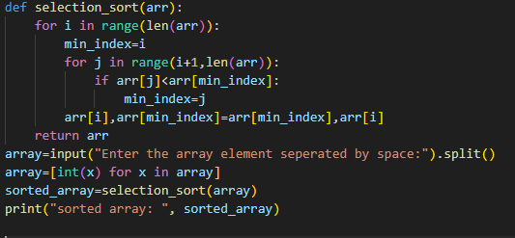

Output:

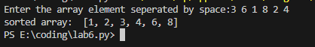

Explanation:

Def- selection -sort ([3,6,1,8,2,4]):

n=len ([3,6,1,8,2,4])

for i in range(6): #i=0

minindex=0

for j in range(i+1,n):

if a[1]<a[0]:

6<3

X

for j in range(2,6):

if a[2]<a[0]

1<3

Minindex=2

for j in range(4,6):

if a[4]<a[2]

2<1

X

for j in range(5,6):

if a[5]<a[2]

4<1

X

a[0],a[2]=a[2],a[0]

a[0],a[2]=1,3

updated array:

|  |  |  |  |  |  |
| --- | --- | --- | --- | --- | --- |
| 0 | 1 | 2 | 3 | 4 | 5 |
| 1 | 6 | 3 | 8 | 2 | 4 |

for i in range(6): #i=1

minindex=1

for j in range(1+1,n)

if a[2]<a[1]:

3<6

Minindex=2

for j in range(3,6):

if a[3]<a[2]

8<3

X

for j in range(4,6):

if a[4]<a[2]

2<3

True

Minindex=j

Minindex=4

for j in range(5,6):

if a[5]<a[4]

4<2

X

a[1],a[4]=a[4],a[1]

a[1],a[4]=2,6

updated array:

|  |  |  |  |  |  |
| --- | --- | --- | --- | --- | --- |
| 0 | 1 | 2 | 3 | 4 | 5 |
| 1 | 2 | 3 | 8 | 6 | 4 |

for i in range(6): #i=3

minindex=3

for j in range(4,6):

if a[4]<a[3]:

6<8

minindex=4

for j in range(5,6):

if a[5]<a[4]:

4<6

Minindex=5

a[3],a[5]=a[5],a[3]

a[3],a[5]=4,8

|  |  |  |  |  |  |
| --- | --- | --- | --- | --- | --- |
| 0 | 1 | 2 | 3 | 4 | 5 |
| 1 | 2 | 3 | 4 | 6 | 8 |

Thus the array is completely sorted in ascending order by the method of selection sort.

LAB#21

**Q.1:** Write a program to sort an unsorted array by using the quick sort algorithm consider first element as a pivot element.

Program:

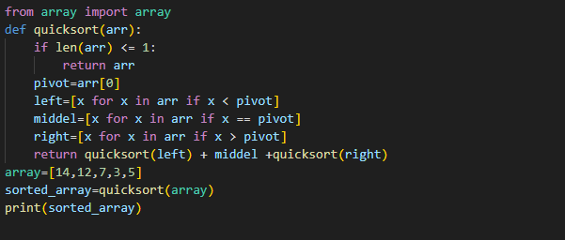

Output:



Explanation:

**1. def quick_sort(arr):**

**If len([14,12,7,3,5])<=1:**

**Return arr**

**Pivot=arr[0]**

**Pivot=14**

**Left= [12,7,3,5]**

**Middle= [14]**

**I return quick_sort([12,7,3,5])+middle**

**1-left🡪quick_sort([12,7,3,5])**

**Middle🡪14**

**quick_sort([12,7,3,5])**

**1-left:**

**def quick_sort(arr):**

**if len[12,7,3,5]<=1**

**X**

**Pivot=arr[0]**

**Left=7,3,5**

**Middle=12**

**Right=[]**

**II return quick_sort[7,3,5]+middle+quick_sort[]**

**1-left-left🡪quick_sort[7,3,5]**

**1-left-middle🡪5**

**1-left-right🡪empty**

**1-left-left:**

**def quick_sort(arr):**

**if len[7,3,5]<=1:**

**X**

**Pivot=arr[0]**

**Left=3,5**

**Middle=7**

**Right=[]**

**1-left-left-left=[3,5]**

**Midde=7**

**return quick_sort[3,5]+middle+quick_sort[]**

**1-left-left-left=[3,5]**

**def quick_sort(arr):**

**if len[3,5]<=1:**

**X**

**Pivot=arr[0]**

**Left=[]**

**Middle=3**

**Right=[5]**

**1-left-left-left-right=5**

**return quick_sort[]+middle+quick_sort[5]**

**1-left-left-left-right=[5]**

**def quick_sort(arr):**

**if len[5]<=1:**

**return 5**

**I return quick_sort([12,7,3,5])+14+quick_sort()**

**return[3,5,7,12,14]**

**sorted_a1=[3,5,7,12,14]**

**Q.2:** Write a program to sort an unsorted array by using the quick sort algorithm consider last element as a pivot element.

Program:

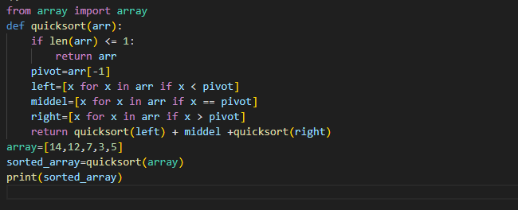

Output:



Explanation:

**1. def quick_sort(arr):**

**If len([14,12,7,3,5])<=1:**

**Return arr**

**Pivot=arr[-1]**

**Pivot=5**

**Left=[3]**

**Middle=[5]**

**Right=[14,12,7]**

**I return quick_sort([3])+middle+quick_sort([14,12,7])**

**1-left🡪quick_sort([3])**

**Middle🡪5**

**1-right🡪quick_sort([14,12,7]**

**1-left:**

**def quick_sort(arr):**

**if len[3]<=1:**

**return 3**

**Now:**

**I return quick_sort[3]+middle+quick_sort[]**

**quick_sort([14,12,7])**

**1-right:**

**def quick_sort(arr):**

**if len[14,12,7]<=1**

**X**

**Pivot=arr[-1]**

**Left=[]**

**Middle=7**

**Right=14,12**

**II return quick_sort[]+7+quick_sort[14,12]**

**1-right-left🡪empty**

**1-right-middle🡪7**

**1-right-right🡪14,12**

**1-right-right:**

**def quick_sort(arr):**

**if len[14,12]<=1:**

**X**

**Pivot=arr[-1]**

**Left=[]**

**Middle=12**

**Right=14**

**1-right-right-right=14**

**1-right-right-middel=12**

**1-right-right-right:**

**def quick_sort(arr):**

**if len[14]<=1:**

**return 14**

**now:**

**III return quick_sort[]+7+quick_sort[14,12]**

**Return [14,12]**

**We have:**

**1-right=[14,12]**

**I return quick_sort([3])+middle+quick_sort([7,12,14])**

**return[3,5,7,12,14]**

**sorted_a1=[3,5,7,12,14]**

**Q.3:** Write a program to sort an unsorted array by using the quick sort algorithm consider any random element as a pivot element.

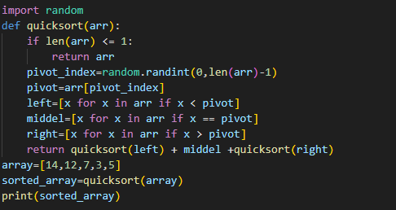

Output:



Explanation:

This program is written for random value of pivot. The value of pivot is randomly chosen but there is no difference on the output of the program.

**LAB#22**

Q: Explain the code (LAB#22 Example#1) in detail.

Program:

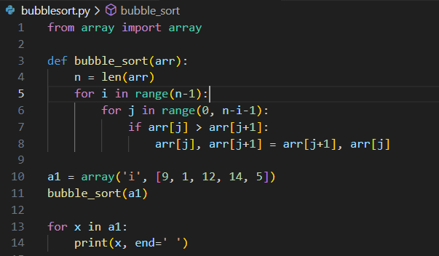

Output:



Explanation of code:

Array= [9,1,12,14,5]

N=len(arr) n=5

I=4 j= (0,3)

J=0

If arr[j] > arr[j+1]

arr[0] > arr[1]

9>1

arr[j],arr[j+1]=arr[j+1],arr[j]

arr[0],arr[1]=arr[1],arr[0]

arr[0],arr[1]=1,9

updated array

1,9,12,14,5

J=1

If arr[j] > arr[j+1]

arr[1] > arr[2]

9>12

X

J=2

If arr[j] > arr[j+1]

arr[2] > arr[3]

12>14

X

J=3

If arr[j] > arr[j+1]

arr[3] > arr[4]

14>5

arr[j],arr[j+1]=arr[j+1],arr[j]

arr[3],arr[4]=arr[4],arr[3]

arr[3],arr[4]=5,14

updated array

1,9,12,5,14

I=3 j= (0,2)

J=0

If arr[j] > arr[j+1]

arr[0] > arr[1]

1>9

X

J=1

If arr[j] > arr[j+1]

arr[1] > arr[2]

9>12

X

J=2

If arr[j] > arr[j+1]

arr[2] > arr[3]

12>5

arr[j],arr[j+1]=arr[j+1],arr[j]

arr[2],arr[3]=arr[3],arr[2]

arr[3],arr[4]=5,12

updated array

1,9,5,12,14

I=2 j= (0,1)

J=0

If arr[j] > arr[j+1]

arr[0] > arr[1]

1>9

X

J=1

If arr[j] > arr[j+1]

arr[1] > arr[2]

9>5

arr[j],arr[j+1]=arr[j+1],arr[j]

arr[1],arr[2]=arr[2],arr[1]

arr[1],arr[2]=5,9

updated array

1,5,9,12,14

Thus the array is sorted in ascending order.

LAB#24

Q: Write a complete explanation of the above code (Example#1 lab#24).

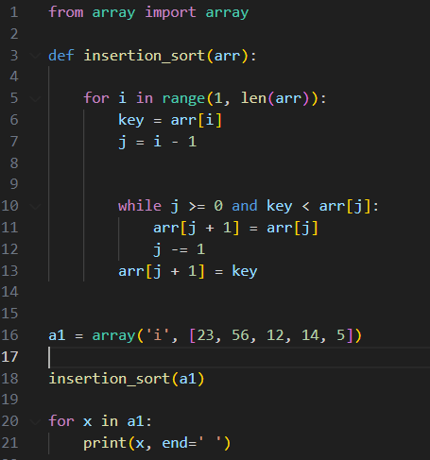

Result:



Explanation of code:

arr=[23,56,12,14,5]

i=(1,5)

i=1

key=56

j=0

if 0>=0 and 56<23

X

arr[1]=56

updated array

23,56,12,14,5

i=2

key=12

j=1

if 1>=0 and 12<56

arr[2]=arr[1]

arr[2]=56

j=0

if 0>=0 and 12<23

arr[1]=arr[0]

arr[1]=23

j=-1

if -1>=0 and 12<23

X

arr[0]=12

updated array

12,23,56,14,5

i=3

key=14

j=2

if 2>=0 and 14<56

arr[3]=arr[2]

arr[3]=56

j=1

if 1>=0 and 14<23

arr[2]=arr[1]

arr[2]=23

j=0

if 0>=0 and 14<12

X

arr[1]=14

updated array

12,14,23,56,5

i=4

key=5

j=3

if 3>=0 and 5<56

arr[4]=arr[3]

arr[4]=56

j=2

if 2>=0 and 5<23

arr[3]=arr[2]

arr[3]=23

j=1

if 1>=0 and 5<14

arr[2]=arr[1]

arr[2]=14

j=0

if 0>=0 and 5<12

arr[1]=arr[0]

arr[1]=12

j=-1

if -1>=0 and 5<12

X

arr[0]=5

updated array

5,12,14,23,56

Thus the array is sorted in ascending order.

LAB#25

**Q.1:** Perform the remaining steps in example#1(LAB#25).

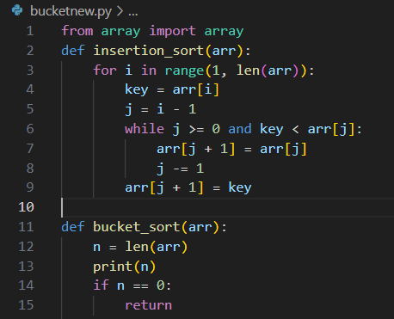 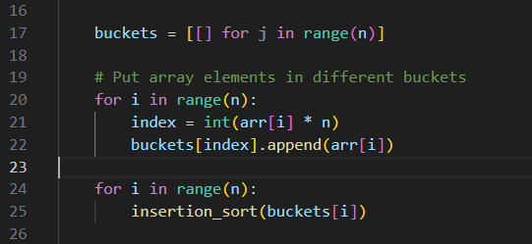

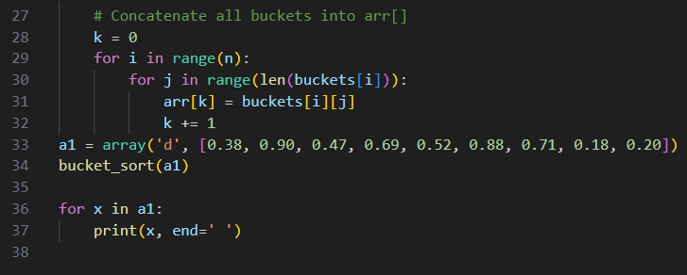

Explanation of the code:

a1=array(‘d’,[0.38,0.90,0.47,0.69,0.52,0.88,0.71,0.18])

bucket_sort(a1)

def bucket_sort(a1):

n=len(a1)

n=9

if n==0:

return

buckets=[[ ] for j in range(n)] #n=9



for i in range(9): #i=0

index=int(arr[i]*n)

index=int(arr[0]*9)

index=int(0.38*9)

index=int(3.42)

index=3

buckets[index].append(arr[0])

buckets[3].append(0.38)

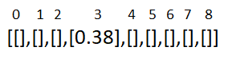

for i in range(9): #i=1

index=int(arr[i]*n)

index=int(arr[1]*9)

index=int(0.9*9)

index=int(8.1)

index=8

buckets[index].append(arr[1])

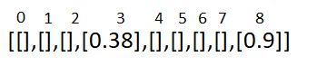 buckets[8].append(0.9)

for i in range(9): #i=2

index=int(arr[i]*n)

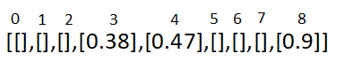 index=int(arr[2]*9)

index=int(0.47*9)

index=int(4.23)

index=4

buckets[index].append(arr[2])

buckets[4].append(0.47)

for i in range(9): #i=3

index=int(arr[i]*n)

index=int(arr[3]*9)

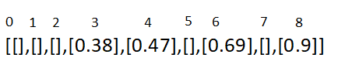 index=int(0.69*9)

index=int(6.21)

index=6

buckets[index].append(arr[3])

buckets[6].append(0.69)

for i in range(9): #i=4

index=int(arr[i]*n)

index=int(arr[4]*9)

index=int(0.52*9)

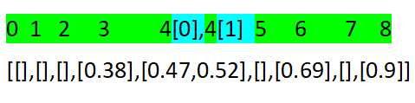 index=int(4.68)

index=4

buckets[index].append(arr[4])

buckets[4].append(0.52)

for i in range(9): #i=5

index=int(arr[i]*n)

index=int(arr[5]*9)

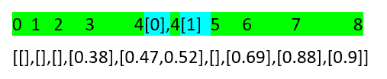 index=int(0.88*9)

index=int(7.92)

index=7

buckets[index].append(arr[5])

buckets[7].append(0.88)

for i in range(9): #i=6

index=int(arr[i]*n)

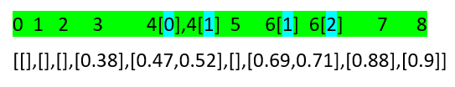 index=int(arr[6]*9)

index=int(0.71*9)

index=int(6.39)

index=6

buckets[index].append(arr[6])

buckets[6].append(0.71)

for i in range(9): #i=7

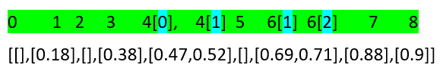 index=int(arr[i]*n)

index=int(arr[7]*9)

index=int(0.18*9)

index=int(1.62)

index=1

buckets[index].append(arr[7])

buckets[1].append(0.18)

for i in range(9): #i=8

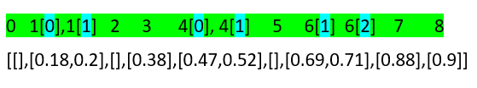 index=int(arr[i]*n)

index=int(arr[8]*9)

index=int(0.2*9)

index=int(1.8)

index=1

buckets[index].append(arr[8])

buckets[1].append(0.20)

for I in range (9)

insertion_sort(buckets[i])

i=1

insertion_sort(0.18,0.20)

i=(0,1)

i=0

key=0.18

j=-1

-1>=0 and 0.18<0

Arr[0]=0.18

I=1

Key=0.20

J=0

0>=0 and 0.20<0

Arr[1]=0.20

Follow this step on other array and the array is sorted in ascending order.

**Q.2:** Create an array of size 10. Instead of using elements from 0 to 1, use elements in the array greater than 1. Then apply the code from example #1 (LAB #25). If you encounter any errors, discuss the error and identify the reason behind it.

Program:

If we create an array of length 10 and the value in the array is greater than 1 then the output of this program is list index out of range. It means that the input value is not within the expected or valid range.

So list index out of range is an error message indicating that the input value is not within the valid range that the program can handle.

LAB#26

Q.1: Take an unsorted array, apply the counting sort algorithm to sort it, and then explain the code in detail, visualizing each step.

Program:  
 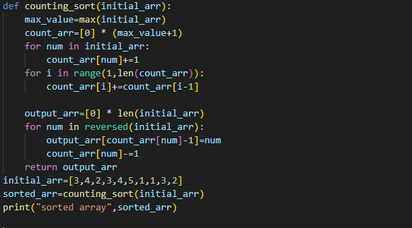

Output:



Explanation of the code:

Initial_arr=[3,4,2,3,4,5,1,1,3,2]

Sorted_arr=counting_sort(initial_arr)

def counting_sort([3,4,2,3,4,5,1,1,3,2]):

max_val=max(initial_arr)

max_val=5

count_arr=[0]*(max_val+1)

count_arr=[0]*6

count_arr=[0,0,0,0,0,0]

|  |  |  |  |  |  |
| --- | --- | --- | --- | --- | --- |
| 0 | 1 | 2 | 3 | 4 | 5 |
| 0 | 0 | 0 | 0 | 0 | 0 |
|  | 1 | 1 | 1 | 1 |  |
|  | 2 | 2 | 2 | 2 | 1 |
|  |  |  | 3 |  |  |
| 0 | 2 | 2 | 3 | 2 | 1 |

Count_arr🡪

for num in initial_arr:

Count_arr[num]=Count_arr[num]+1

Count_arr[3]=Count_arr[3]+1=0+1=1

Count_arr[4]=Count_arr[4]+1=0+1=1

Count_arr[2]=Count_arr[2]+1=0+1=1

Count_arr[3]=Count_arr[3]+1=1+1=2

Count_arr[4]=Count_arr[4]+1=1+1=2

Count_arr[5]=Count_arr[5]+1=0+1=1

Count_arr[1]=Count_arr[1]+1=0+1=1

Count_arr[1]=Count_arr[1]+1=1+1=2

Count_arr[3]=Count_arr[3]+1=2+1=3

Count_arr[2]=Count_arr[2]+1=1+1=2

Count_arr=

|  |  |  |  |  |  |
| --- | --- | --- | --- | --- | --- |
| 0 | 1 | 2 | 3 | 4 | 5 |
| 0 | 2 | 2 | 3 | 2 | 1 |

Now, store the result of cumulative sum in the Count_arr:

|  |  |  |  |  |  |
| --- | --- | --- | --- | --- | --- |
| 0 | 1 | 2 | 3 | 4 | 5 |
| 0 | 2 | 2 | 3 | 2 | 1 |
| 0 | 2 | 4 | 7 | 9 | 10 |

Count_arr 🡪

for i in range(1,len(Count_arr)):

Count_arr[i]=Count_arr[i]+Count_arr[i-1]

#i=1 Count_arr[1]=Count_arr[1]+Count_arr[1-1]

= Count_arr[1]+Count_arr[0]

=2+0=2

#i=2 Count_arr[2]=Count_arr[2]+Count_arr[2-1]

= Count_arr[2]+Count_arr[1]

=2+2=4

#i=3 Count_arr[3]=Count_arr[3]+Count_arr[3-1]

= Count_arr[3]+Count_arr[2]

=3+4=7

#i=4 Count_arr[4]=Count_arr[4]+Count_arr[4-1]

= Count_arr[4]+Count_arr[3]

=2+7=9

#i=5 Count_arr[5]=Count_arr[5]+Count_arr[5-1]

= Count_arr[5]+Count_arr[4]

=9+1=10

Updated Count_arr:

|  |  |  |  |  |  |
| --- | --- | --- | --- | --- | --- |
| 0 | 1 | 2 | 3 | 4 | 5 |
| 0 | 2 | 4 | 7 | 9 | 10 |

Output=[0]*len(initial_arr)

=[0]*10

Output=[0,0,0,0,0,0,0,0,0,0]

Now, we have:

|  |  |  |  |  |  |  |  |  |  |
| --- | --- | --- | --- | --- | --- | --- | --- | --- | --- |
| 0 | 1 | 2 | 3 | 4 | 5 | 6 | 7 | 8 | 9 |
| 3 | 4 | 2 | 3 | 4 | 5 | 1 | 1 | 3 | 2 |

|  |  |  |  |  |  |
| --- | --- | --- | --- | --- | --- |
| 0 | 1 | 2 | 3 | 4 | 5 |
| 0 | 2 | 4 | 7 | 9 | 10 |

|  |  |  |  |  |  |  |  |  |  |
| --- | --- | --- | --- | --- | --- | --- | --- | --- | --- |
| 0 | 1 | 2 | 3 | 4 | 5 | 6 | 7 | 8 | 9 |
| 0 | 0 | 0 | 0 | 0 | 0 | 0 | 0 | 0 | 0 |

Initial_arr

Count_arr

Output_arr

for num in reversed(initial_arr):

#num=2

Output_arr[Count_arr[2]-1]=2

Output_arr[4-1]=2

Output_arr[3]=2

Count_arr[2]=Count_arr[2]-1

=4-1

Count_arr[2]=3

#num=3

Output_arr[Count_arr[ 3]-1]=3

Output_arr[7-1]=3

Output_arr[6]=3

Count_arr[3]=Count_arr[3]-1

=7-1

Count_arr[3]=6

#num=1

Output_arr[Count_arr[1]-1]=1

Output_arr[2-1]=1

Output_arr[1]=1

Count_arr[1]=Count_arr[1]-1

=2-1

Count_arr[1]=1

#num=1

Output_arr[Count_arr[1]-1]=1

Output_arr[1-1]=1

Output_arr[0]=1

Count_arr[1]=Count_arr[1]-1

=1-1

Count_arr[1]=0

#num=5

Output_arr[Count_arr[5]-1]=5

Output_arr[10-1]=5

Output_arr[9]=5

Count_arr[5]=Count_arr[5]-1

=10-1

Count_arr[5]=9

#num=4

Output_arr[Count_arr[4]-1]=4

Output_arr[9-1]=4

Output_arr[8]=4

Count_arr[4]=Count_arr[4]-1

=9-1

Count_arr[4]=8

#num=3

Output_arr[Count_arr[3]-1]=3

Output_arr[6-1]=3

Output_arr[5]=3

Count_arr[3]=Count_arr[3]-1

=6-1

Count_arr[3]=5

#num=2

Output_arr[Count_arr[2]-1]=2

Output_arr[3-1]=2

Output_arr[2]=2

Count_arr[2]=Count_arr[2]-1

=3-1

Count_arr[1]=2

#num=4

Output_arr[Count_arr[4]-1]=4

Output_arr[8-1]=4

Output_arr[7]=4

Count_arr[4]=Count_arr[4]-1

=8-1

Count_arr[4]=7

#num=3

Output_arr[Count_arr[3]-1]=3

Output_arr[5-1]=3

Output_arr[4]=3

Count_arr[3]=Count_arr[3]-1

=5-1

Count_arr[2]=4

Return Output_arr

[1,1,2,2,3,3,3,4,,5]

LAB#27

Q.1: Consider the below code (Lab#27 example#1)then explain the code in detail, visualizing each step

.Program:

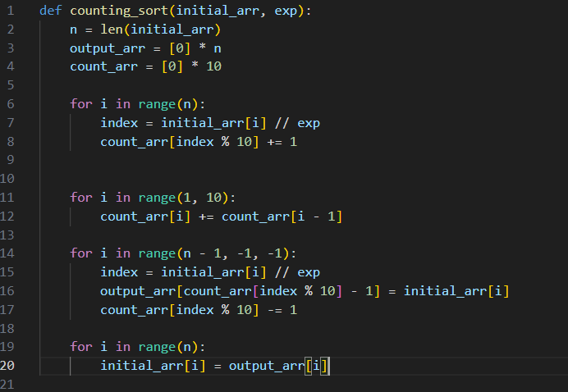

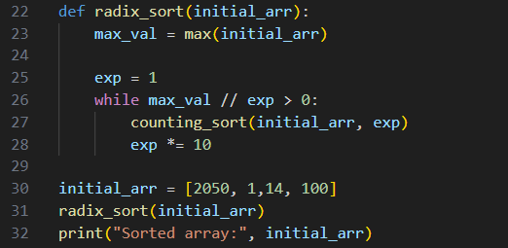

Output:



Explanation:

Radix_sort=[2050,1,14,100]

Def radix_sort(2050,1,14,100)

Max_value=2050

Exp=1

While 2050//1 >0:

Counting_sort([2050,1,14,100],1)

N=4

Output_arr=[0,0,0,0]

Count_arr=[0,0,0,0,0,0,0,0,0,0]

For I in range(0,3)

I=0

Index=2050//1

Index=2050

Count_arr[2050%10]+=1

Count_arr[0]+=1

I=1

Index=1//1

Index=1

Count_arr[0%10]+=1

Count_arr[1]+=1

I=2

Index=14//1

Index=14

Count_arr[14%10]+=1

Count_arr[4]+=1

I=3

Index=100//1

Index=100

Count_arr[100%10]+=1

Count_arr[0]+=1

Updated count_arr=[2,1,0,0,1,0,0,0,0,0]

For I in range(1,10)

Count_arr[i]=count_arr[i]+count_arr[i-1]

Count_arr[1]=1+2

Count_arr[1]=3

Count_arr[2]=0+3

Count_arr[2]=3

Count_arr[3]=0+3

Count_arr[3]=3

Count_arr[4]=1+3

Count_arr[4]=4

Count_arr[5]=0+4

Count_arr[5]=4

Count_arr[6]=0+4

Count_arr[6]=4

Count_arr[7]=0+4

Count_arr[7]=4

Count_arr[8]=0+4

Count_arr[8]=4

Count_arr[9]=0+4

Count_arr[9]=4

Updated count_arr=[2,3,3,3,4,4,4,4,4,4]

For I in range(0,2)

I=0

Index=2050//1

Index=2050

Output_arr[count_arr[index%10]-1]=initial_arr[i]

Output_arr[count_arr[0]-1=initial_arr[0]

Output_arr[2-1]=initial_arr[0]

Output_arr[1]=2050

Count_arr[0]-=1

I=1

Index=1//1

Index=1

Output_arr[count_arr[index%10]-1]=initial_arr[i]

Output_arr[count_arr[1]-1=initial_arr[1]

Output_arr[3-1]=initial_arr[1]

Output_arr[2]=1

Count_arr[2]-=1

I=0

Index=2050//1

Index=2050

Output_arr[count_arr[index%10]-1]=initial_arr[i]

Output_arr[count_arr[0]-1=initial_arr[0]

Output_arr[2-1]=initial_arr[0]

Output_arr[1]=2050

Count_arr[2]-=1

I=0

Index=2050//1

Index=2050

Output_arr[count_arr[index%10]-1]=initial_arr[i]

Output_arr[count_arr[0]-1=initial_arr[0]

Output_arr[2-1]=initial_arr[0]

Output_arr[1]=2050

Count_arr[2]-=1

LAB#28

Q.1: Perform a detail dry run of the below code(LAB#28 Q.1) with a visual explanation for each step.

Solution:

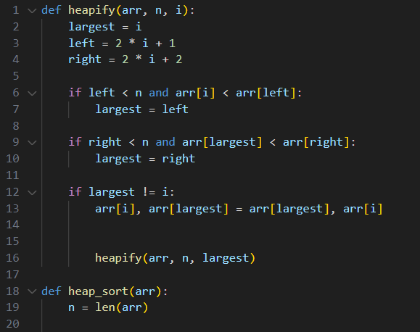

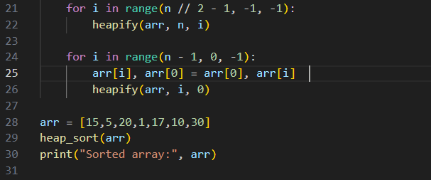

Result:



Explanation of code:

Heap_sort(15,5,20,1,17,10,30)

def heap_sort(15,5,20,1,17,10,30)

n=7

for I in range(7//2-1)

I in range(0,2)

I=0

Heapify([15,5,20,1,17,10,30],7,0)

Largest=0

Left=1

Right=2

If 1<7 and 15<5:

Largest=1

If 2<7 and 5<20

Largest=2

If 2!=0

Arr[0],arr[2]=arr[2],arr[0]

Arr[0],arr[2]=20,15

Updated array=[20,5,15,1,17,10,30]

Heapify([20,5,15,1,17,10,30],7,2)

Largest=2

Left=5

Right=6

If 5<7 and 15<10:

X

If 6<7 and 15<30

Largest=6

If 6!=2

Arr[2],arr[6]=arr[6],arr[2]

Arr[2],arr[6]=30,15

Updated array=[20,5,30,1,17,10,15]

Heapify([20,5,30,1,17,10,15],7,6)

Largest=6

Left=13

Right=14

If 13<7 and 15<0

X

If 14<7 and 15<0

X

If 6!=6

X

I=1

Heapify([20,5,30,1,17,10,15],7,1)

Largest=1

Left=3

Right=4

If 3<7 and 5<1:

X

If 4<7 and 5<17

Largest=3

If 3!=1

Arr[1],arr[3]=arr[3],arr[1]

Arr[1],arr[3]=1,5

Updated array=[20,1,15,5,17,10,

Heapify([20,1,15,5,17,10,30],7,3)

Largest=3

Left=5

Right=6

If 5<7 and 5<10:

Largest=5

If 6<7 and 10<30

Largest=6

If 6!=3

Arr[3],arr[6]=arr[6],arr[3]

Arr[3],arr[6]=30,5

Updated array=[20,5,30,1,17,10,5]

Heapify([20,5,30,1,17,10,15],7,6)

Largest=6

Left=13

Right=14

If 13<7 and 15<0

X

If 14<7 and 15<0

X

If 6!=6

X

I=2

Heapify([20,5,30,1,17,10,15],7,2)

Largest=2

Left=5

Right=6

If 5<7 and 30<10:

X

If 6<7 and 30<15

If 2!=2

X

Same as it is the program execute and the array is sorted in ascending order and the last output is

[1,5,10,15,17,20,30]

LAB#29

Q#1: Write a program to create a priority queue by using linked list.

Your program must include all the functions that we used in Example #1 from Lab #29, such as push (), pop (), and others.

Program:

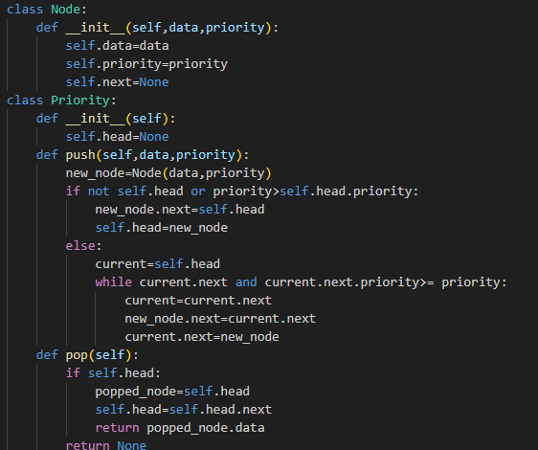

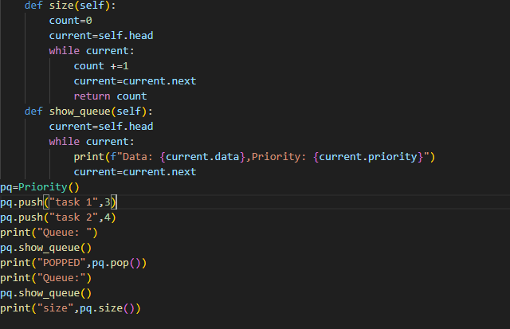

Output:

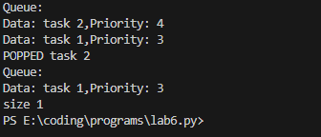

LAB#30

Q#1: Write a program to create a doubly linked list, then apply a sorting algorithm to arrange the item in ascending order.

Program:

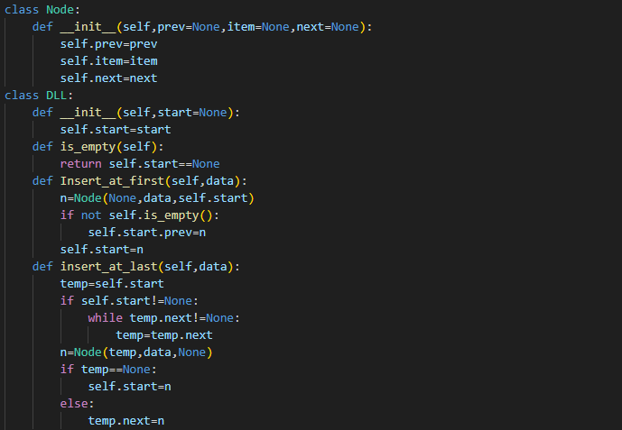

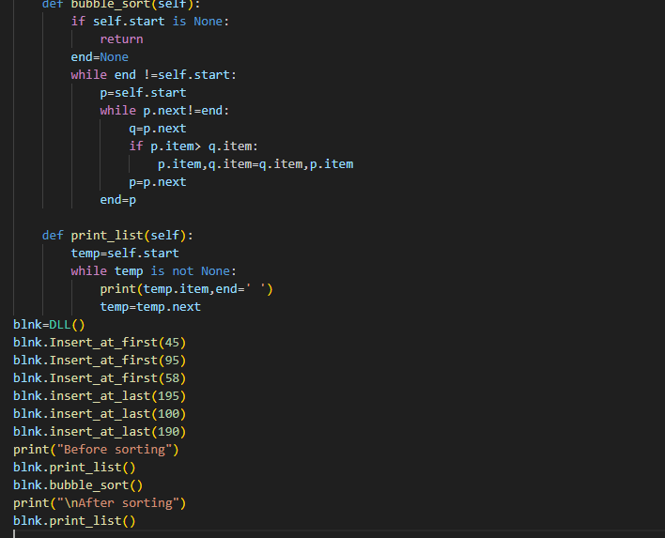

OUTPUT:

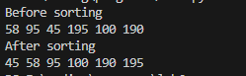LAB#31

Q#1: Write a program to merge different unsorted arrays then apply linear search algorithm to search a particular element from that array.

Program:

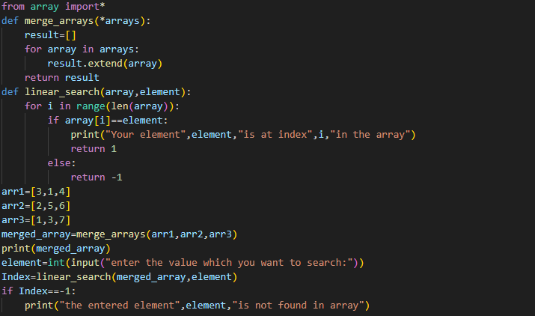

Output:

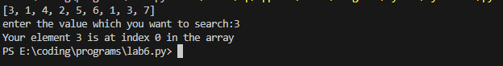

Q#2: Write a program to merge different unsorted arrays then sorted the array in ascending order and then apply the binary search algorithm to search a particular element from that array.

Program:

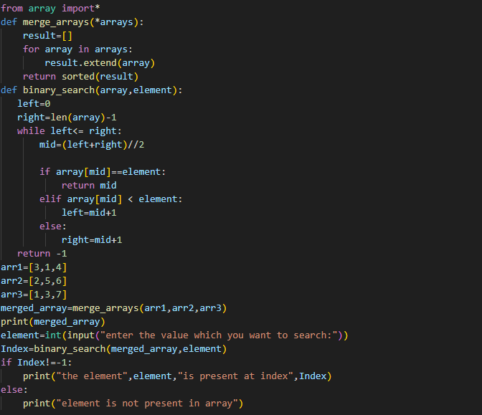

Output:

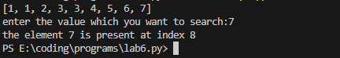

The End